The Aoyama Portal for submitting grades, downloading rosters, inputting syllabi, etc. Updated 28 March 2014

- Using the Aoyama Portal

Teachers are encouraged to use the Aoyama Portal to download class rosters and to submit grades. Teachers of elective classes are encouraged to also use the Aoyama Portal to upload course descriptions (course descriptions for required courses in the regular English program will be uploaded by the department) and to reply to exam questionnaires (to give students and Kyomuka the details of any final exams or reports for your class). Further instructions in Japanese for using the Aoyama Portal will be sent by the university. Please visit the PC Support Lounge on the first floor of Building 2 if you need further assistance. The instructions given here provide only a basic summary of the steps you need to take to access your records.

- Before you start

Before accessing the Aoyama Portal you need to go the PC Support Lounge on the first floor of Building 2 to do the following:

- Register a PIN password in order to access the Aoyama Portal from computers on campus which have a card reader for university identity cards.

- Register a separate LDAP password in order to access the Aoyama Portal from your home computer or any other computers which do not have a card reader for university identity cards. (This is the same LDAP password that you need to access the AFP World Academic Archive.)

- Register a matrix pattern (Securematrix password) for accessing classified or highly confidential information (regardless of the type of computer you plan to use).

- Accessing the Aoyama Portal

To access your personal information on the Aoyama Portal, the following steps must be taken:

- If you are accessing the Aoyama Portal from a computer on campus which has a reader for your university ID card, enter your PIN password into the field marked "PINを入力" (“Enter PIN”). You will automatically be directed to the Aoyama Portal.

- If you are accessing the Aoyama Portal from your home computer or any other computer that does not have a card reader for your university ID card, follow these steps:

- Enter <https://aoyama-portal.aoyama.ac.jp/> into your Internet browser. For Windows PC users, you must use Internet Explorer 32 bit (not 64 bit) encryption.

- Enter the number on your university ID card into the field marked "ログインID" (“Login ID”).

The first digit of the number on your university ID card must be converted to a lower case t. For example, if the number on your university ID card is 000919, the number you should enter into the field marked "ログインID" (“Login ID”) is t00919.
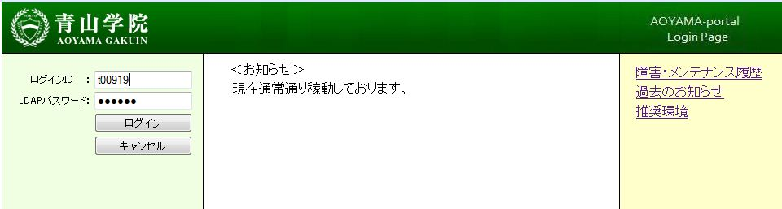

- Enter your LDAP password into the field marked "LDAP パスワード" (“LDAP Password”)
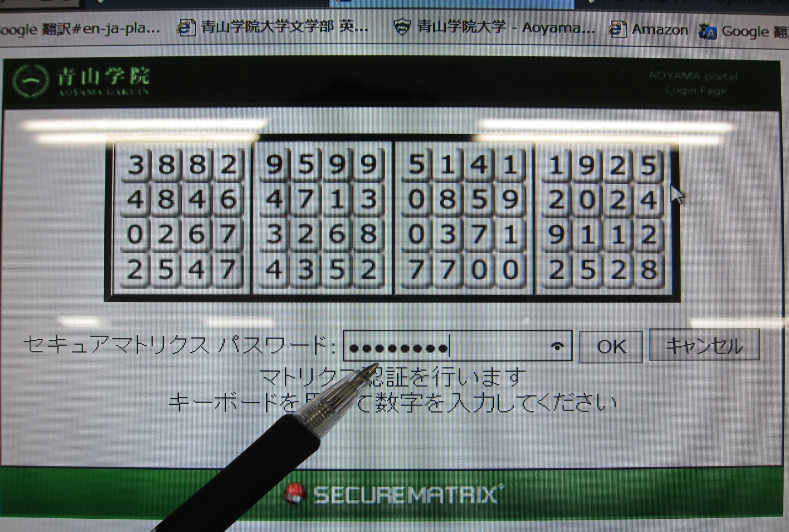

- Enter the 8-digit numbers from the matrix based on the pattern you registered with the PC Support Lounge. Type the numbers into the blank and click on “OK.”

- If you are logging in at home and you use a MAC, you may have to update your version of JAVA. Alternately, if you are on a PC and the sign comes up for the visual matrix, you may be able to do a “work-around,” simply paste in the same URL as before, and press return:

https://jimweb.jm.aoyama.ac.jp/kyweb/Menu2.aspx

- Opening Your Teacher Records
A new screen will appear with your name on it. The left hand side of the screen will have a menu of options. Scroll down it until you see (KYOIN WEB) 教員事務WEB.

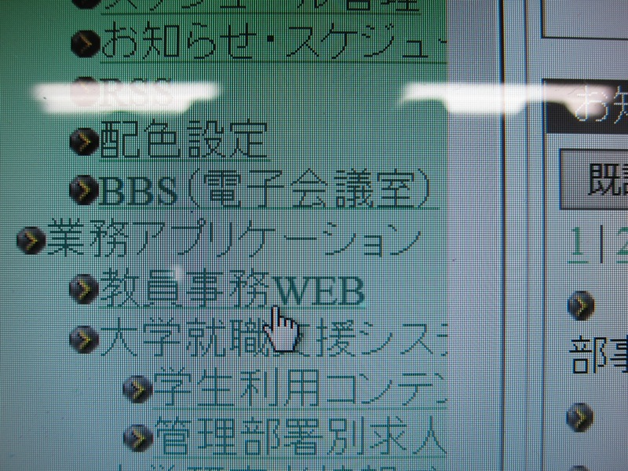

- Clicking on this icon will take you to another page.

