ACADEMIC WRITING 2014 TEACHERS’ GUIDE
Academic Writing is the most difficult course in the IE Program. Many more students fail this course than any other and all agree on its difficulty. At this point, a capsule review of the history of this course may be in order. For more than 19 years, the English Department has offered an Academic Writing course. At its weakest, a few teachers interpreted this course to mean that students would work on paragraph writing until they could produce sentences that were error-free. Most teachers, however, agreed on the need to develop their students’ understanding of the “academic genre” of essay writing.

The course was re-organized some nine years ago after student complaints about the overlap between the essay assignments in IE Writing II and III, and those in Academic Writing. After a needs analysis of students in their junior and senior years, we developed a new course focusing on research skills and on quoting and paraphrasing source material. Many Japanese students have not had much opportunity to develop research skills, nor critical reading and thinking, due to the emphasis on facts and recognition in high school education.

The Academic Writing text includes information about assignments and extensive examples of the MLA Style. An important aspect of the new Academic Writing course is to develop these skills through library research activities. The differences between the courses and their objectives are shown below:

IE Writing I | IE Writing II | IE Writing III | Academic Writing
Paragraph Writing:  1) Description  2) Classification  3) Comparison-  Contrast | Introduction to  the Essay  (350 words each):  1) Comparison-  Contrast  2) Analysis | MLA Style for  references and  quotations in 2  essays of 350 words:  1) Classification  2) Persuasion | A 1,500-word Research Essay:  1) Creating a bibliography  2) Citing references in the MLA style

Please note the word-length for each of the essays. We ask you to use these lengths in your class and in fairness to your students, avoid longer or shorter assignments. Students inevitably compare assignments from one class to another and they will complain it they perceive that they are being treated differently in your class.

Even though Academic Writing is a very difficult course, it is only one semester in length. You will need to take extra care to keep track of your students and to warn some of them as they fall behind. Please collect contact telephone numbers and e-mail addresses from them in the first class in order to keep track of those students who have difficulty in keeping up with the class. All the same, as in other courses, you need a warm relationship with your students, rather than hectoring them on due dates and rewrites.

CONTENTS

I. | SCOPE AND SEQUENCE ..…………………………..............  (a) Essay Specifications  (b) Sequence of Instruction  (c) Grading Assignments  (d) Word-Processing Assignments  (e) Accessing the Library  (f) Accessing AGU’s Online Databases  (g) Your Class as a Writing Community | 4
II. | TEACHING THE MLA STYLE ……………………………….... (a) Citing Electronic Resources  (b) In-Text Citations | 15
III. | ADDRESSING PLAGIARISM …………………………………  (a) Defining Plagiarism  (b) Detecting Plagiarism  (c) Using Quotations  (d) Paraphrasing and Summarizing  (e) Note-Taking | 22
IV. | CLASSROOM ACTIVITIES ….………………………………… | 27
V. | GRAMMATICAL ERRORS …………………………………….. | 29
VI. | RESPONSES TO WRITING ...…………………………………  (a) A Protocol For Conferencing  (b) Recorded Conferences  (c) Marking Symbols  (d) Commenting Online | 30
VII. | PRESENTATIONS .…………………………………………….. | 34
VIII. | A GRADING SCHEDULE …………………………………….... | 35
IX. | ESSAY RATING SCALES …………………………………..….. | 35
X. | GROUP RATINGS ………………………….…………………….  (a) Teacher Comments  (b) Student Models | 38
XI. | TEACHER RESOURCES .………………………………………  (a) Further References | 39
XII. | MARKING SYMBOLS ..………………….……………………… | 41
About this Teachers’ Guide:
- Use it in tandem with the exercises in the Academic Writing Student Booklet, including those on paraphrasing, summarizing, and creating a thesis;

- As longs as student topics fall within the broad category of English Literature, Linguistics, and Communication (ie. Film, Music, other Media), encourage your students to follow their interests;

- While it can be useful to teach students a few discrete grammar points such as the use of the colon and semi-colon, student feedback on their evaluations indicates that teaching grammar can be demotivating to them. Grammar correction should be given on an individual basis and within the context of a piece of student writing.

- When showing examples from students’ papers in class, please respect their privacy and conceal their identities, especially when criticising their work;

- Help your students’ to manage the writing process by breaking up the research essay task into manageable parts. This will help them avoid last-minute efforts as well as the temptation to plagiarize.

- Keep the essay task to 1,500 words to maintain consistency between our Academic Writing classes.

- Ensure that the teacher-student conferences are short and well-structured. An even more effective approach is to have your students record the conference on their cell phones.

- Mark and respond to at least two entire drafts of the essay from each student.

- We strongly urge you to ask students to use their recording function on their i-pods and cell phones when you conference with students. Research, response from student evaluations, anecdotal reports from AW teachers, all point to the success of this method as students can replay your comments at home.

We have included many activities and as much information as we could in the Academic Writing Student Booklet to save you from copying class sets of exercises and student models. Meanwhile this Academic Writing Teachers’ Guide includes additional suggestions for classroom activities, further references, and answer keys for the JSTOR library activity and for rating sample student essays. In this guide, we have also included Internet resources, some of which are meant to be used as demonstration in class.

A class text that many teachers have found useful in planning additional classroom activities is Writing Academic English (4th ed.) by Alice Oshima and Ann Hogue (2006). It includes a very helpful section on writing an essay and exercises on doing paraphrases and on using quotations, and with developing a bibliography.

A full reference for it and other reference books is included at the end of these notes.
Because the student booklet has such an extensive list of examples of proper MLA documentation, we no longer ask students to purchase additional references although you may certainly use other books as a teacher’s reference or to show on the OHC.

First and second year students are required to take computer courses in using MS Word, so all of their assignments must be typed and the spelling corrected (as this can be easily checked on their computers). This also enables teachers to easily test students’ writing for plagiarism by entering phrases from a student’s essay into a “Google search.”

I. SCOPE AND SEQUENCE
There are three major goals in Academic Writing: (1)a review of the writing process introduced in IE Writing, (2)the use of evidence, (3)critical analysis. Learning objectives are associated with each one. Classroom activities should support these objectives.

1. The Writing Process: Each student should take his or her research essay
through the stages of brainstorming ideas, drafting, peer tutorial, and
revision.

By the end of the course, a student should:
(a) understand and use the writing process including brainstorming,
drafting, revising
(b) identify problems in his or her writing
(c) know how to evaluate other students' writing and comment upon it
(d) be able to revise his or her writing according to the feedback from
other students and the teacher.

Although the writing process is taught to students in the Writing Sections of the Integrated English Program, you should review it in Academic Writing. The analytic essay in Academic Writing is quite different than the traditional impressionistic Japanese essay, kishoutenketsu, which links ideas by association rather than by argument.

Websites for brainstorming, particularly mind-mapping:
http://en.wikipedia.org/wiki/Mind_map
http://www.buzanworld.com/Mind_Maps.htm
http://www.imindmap.com/

http://www.youtube.com/watch?v=MlabrWv25qQ
http://images.google.com/images?um=1&hl= en&client=safari&rls=en-us&q= mind+mapping&btnG=Search+Images

In addition, students must use avoid use of the first person. Time should be spent on brainstorming and developing thesis statements in particular.

2. Evidence Each student should understand the principle of proposition
and support. A student also needs to understand the difference
between doing original work and using sources. You should be able to
recognize plagiarism and know how to avoid it.

After completing the course, a student should have the ability to:
(a) locate reference materials in the library and on the internet
including encyclopedias, subject area books, journals, and
newspapers
(b) create a bibliography for a research essay
(c) paraphrase material
(d) use quotations from references
(e) integrate quotations in an argument
(f) take notes on sources for writing purposes

3. Critical Thinking – Each student should learn how to read critically.
A student should be able to distinguish between facts and opinions.
A student should develop his or her ability to:
(a) outline the organization of an essay
(b) analyze the logic in written arguments
(c) identify the perspective of an essay
(d) explain their ideas in a short oral presentation

A great tutorial for learning how to exercise critical thinking in evaluating websites: http://www.vts.intute.ac.uk/detective/
Also refer students to pages 18-20 of the Academic Writing Students Booklet to learn more about critical thinking.

Additional Internet resources:
http://www.vts.intute.ac.uk/detective/
http://en.wikipedia.org/wiki/Critical_thinking
http://www.criticalthinking.org/
http://www.youtube.com/watch?v=HmsvIl2flL0
http://www.youtube.com/watch?v=FJ8biQB9Aac
http://www.youtube.com/watch?v=RKHjR5j5Fmg

http://images.google.com/images?hl=en&client=safari&rls=en-us&resnum=0&q=critical% 20thinking&um=1&ie=UTF-8&sa=N&tab=wi

I.(a) ESSAY SPECIFICATIONS
Likely, none of our students have ever written an essay of 1,500 words, so the course will challenge them. Their finished research papers should include the following:
(a) a minimum of 1,500 words, word-processed, and spell-checked
(b) an introductory paragraph which discusses the background to the question being
addressed in the essay
(c) an appropriate thesis statement and topic sentences
(d) a bibliography of several books recorded in the MLA Style, including a general
reference such as an encyclopedia, as well as journals and magazine references
noted in either English or Japanese (in roman characters)
(e) a use of quotations where appropriate, but an emphasis on paraphrasing quotations
(f) effective transitions between paragraphs, examples within paragraphs, and major
sections of the essay
(g) varied sentence construction.
(h) a final draft of the essay which communicates the students’ ideas effectively although
it will contain grammatical errors

I.(b) SEQUENCE OF INSTRUCTION
The following sequence of instruction represents the 11 steps in a semester-length course. It may take one class or even several classes to complete a single step. There are activities and exercises in both the Academic Writing Student Booklet and in this guide to assist you.

For example, page 7 of the booklet contains an exercise to help you in getting students to define their topics. There are often Some of the homework assignments should be marked and form part of the final grade.

In preparing the students for seminar discussions in their junior and sophomore years, and for providing a sense of closure on the essay, we ask you to assign them a short presentation on their essays (Step 11).

Step 1: | Parts of a Research Paper  - review the parts of an essay, handouts  - distinguish between a simple essay and a research paper  - discuss sample topics with students (See page 35 in the  Appendix of the student booklet)  - brainstorm ideas for topics | HW  ~list 2 or 3  potential topics,  bring books
Step 2: | Preparing Students to use the Library  - identify several possible topics  - review a sample bibliography (See the sample essays  from page 76 onward in the Appendix of the student  booklet)  - learn the different types of MLA citations through the  examples in the student booklet from page 14 onward  - learn how to make bibliographic entries for newspapers and magazines; correct in peer groups  - emphasize the types of notes to keep track of references (ie. author, year, etc.) | HW  ~make a practice  bibliography of 3 types of items
Step 3: | Optional Library Tour  - do a library orientation activity (See the activities on page  40 in the Appendix of the student booklet)  - demonstrate the catalogue and journal search (See pp.  10-13; also student booklet)  - identify some general references and other materials  related to particular student topics  - optionally, provide students with information about using  internet search engines and demonstrate them | HW  ~take notes, find  references ~prepare  preliminary  bibliography

Step 4: | Refining the Topic into a Thesis  - developing a thesis by posing a question to be answered by the research paper  - consider types of questions to be answered  - board examples, small group work | HW  ~create a thesis  statement

Step 5: | Outlining the Research Paper  - sample outlines shown in class (See page 45 in the  Appendix of the student booklet)  - think-pair-share activities  - show-and-tell” references in small groups | HW  ~create a rough  outline
Step 6: | Start Introductory Paragraph  - use of comparisons, cause and effect, definitions, and  analyses  - board examples, handouts  - small group work, prepare topic sentences | HW  ~topic sentences
Step 7: | Identify Quotations  - review topic sentences, and references  - find suitable quotations  - explain how quotations may be paraphrased  - class exercises in paraphrasing  - show how quotations and authors’ names can be  placed within texts in the MLA Style | HW  ~ begin first draft  note page  references
Step 8: | Work-in Progress  - in groups, student comments about one another’s essays | HW  ~ continue 1st  draft
Step 9: | Peer Responses to 1st Drafts  - small group discussions  - teacher joins groups  - emphasis on transitions, cohesion and variety | HW  ~ revisions, first  draft for the  teacher
Step 10: | Teacher Response and Conferencing  - papers returned for next draft  - small group revision  - students prepare for their oral presentation through talking to small groups and (possibly) recording them | HW  ~ 3rd, possibly 4th  drafts of papers  ~ prepare oral  presentations
Step 11: | Oral Presentations and Final Reading  - before handing in their papers, students make short oral  presentations with notecards, and try to avoid reading.

*Even short 3-5 min. conferences with students will mean about 1-2 classes. Please structure your class so that students are revising mistakes or reviewing their work or preparing questions to ask you during their conference. Do not dismiss students from class if they are working ahead of the group. Allow them to use the class as a study/work period or to prepare for their presentations.

In the last class, listen to the remaining presentations, and perhaps conference with the weakest students. You might ask them for a further revision to their paper in order to give them a passing grade for the course.

LIBRARY ORIENTATION
2 min | How to start | Getting information from the internet or a library book
4 min | Types of materials | ▪ basic --- encyclopedias  ▪ technical things --- scholarly journal  ▪ current events --- newspaper, internet
15 min | How to look up books | ▪ The catalogue system  ▪ How to find books at AGU and at other libraries
15 min | How to find magazine articles | How to find magazine articles using “ProQuest”
18 min | How to find newspaper articles | Search using the database “Proquest Newspaper”
30 min | Student practice

I.(c) GRADING ASSIGNMENTS
Because of the number of assignments in the course and the importance of homework assignments and attendance, accurate record-keeping is essential. To facilitate this, we have purchased site licenses for two software grading programs. For this course, where there are usually 9 different assignments, the easiest grading option is http://www.engrade.com/ which can be run on iphones, ipads, androids and PCs and Macs. It’s a simple database in which students’ names are easily entered and grades altered easily, too. As well, the English department has licences for Gradeguide 5.5, which runs on Windows platforms and EASY Grade Pro 4.5, a more comprehensive grading program designed for U.S. public schools, which tracks attendance and seating as well as grades, and runs on both MAC and Windows platforms. Either system will enable you to keep your marks in the most efficient way possible and avoid the human error in assessment that comes with the use of a handheld calculator.

Either program also can provide you with student aliases, so that you can post your student’s marks, grade averages, and adjust their scores. Copies of the software programs and instructions may be signed out by asking Greg or Joseph.

In order to evaluate your students accurately, and to encourage them to meet deadlines and to prepare adequately for class, you should give them a schedule. The schedule should include homework assignments that are part of developing a research essay. This will help to prevent students from procrastinating. The remaining 5 marks might include class participation and attendance.
 | Due Date | Points
Practice Bibliography  Bibliography  Thesis Statement and Outline  Notecards of Quotations  1st Draft  Revised Draft for Teacher  Final Draft  Oral Presentation  Participation  ____________________ |  | 2  8  15  10  15  15  20  10  5  ______

I.(d) WORD-PROCESSING ASSIGNMENTS
Computers should be used for every assignment in Academic Writing. That way, students can more easily revise their work. By their sophomore year, because every student has been required to pass several modules on word-processing, power-point, and using a database, they come to your class with the ability to use these programs. We also strongly urge you to get your students to utilize the spelling and grammar checks built into MS Word. In the former case, this might be done by giving them an extra point for perfect spelling in an assignment.

I. (e) USE AND MISUSE OF WIKIPEDIA
Point out to students that Wikipedia can very be inaccurate. Students should utilize a variety of resources, library books and online resources. About.com is a good alternative to Wikipedia as the articles all have authors and are therefore more reliable. At the very least, students should be directed to follow the links at the bottom of most Wikipedia entries. These often link to newspaper and journal items.

Here is an example of a flawed Wikipedia reference that became famous.
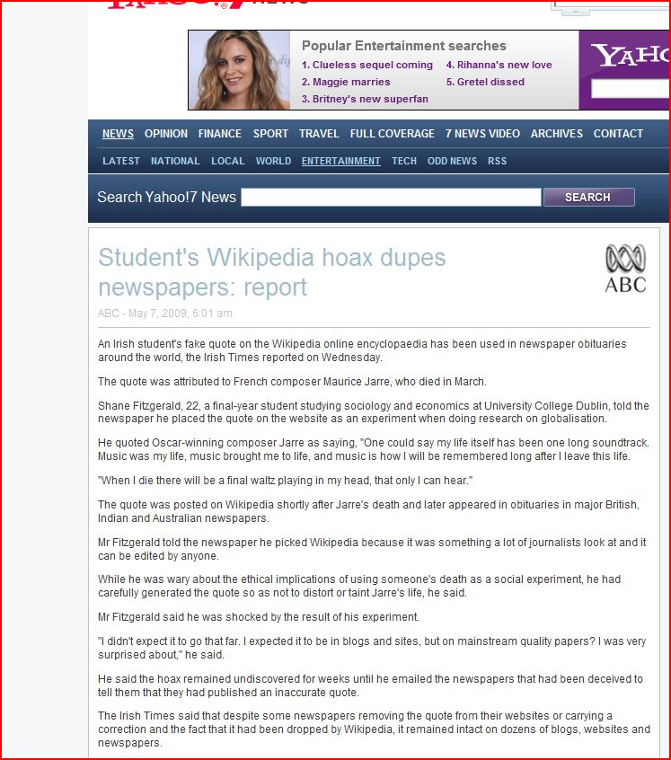

http://au.news.yahoo.com/a/-/entertainment/5548995

I. (f) ACCESSING THE LIBRARY CATALOGUE
The library catalogue consists of holdings at the Sagamihara, Aoyama campus, and the Junior College (both at Shibuya) can be accessed from anywhere. You can also arrange to have books delivered from one campus to another. Teachers can sign most books out for several months, but students are only allowed a 2-week loan period.

accessing the library collection:
http://www.agulin.aoyama.ac.jp/opac/

opening directly to OPAC:
http://www.agulin.aoyama.ac.jp/opac/imain_en_euc-jp.html

The screen will change languages and you can type in searches by title, author, key word, or subject.

other online library resources:
the Educational Resources Information Centre, ERIC
http://eric.ed.gov/

the Librarians Internet Index
http://www.ipl.org/

I. (g) ACCESSING AGU’s ONLINE DATABASES
If you take students to the library, please demonstrate to them how they can access journal articles through the AGU Library database of electronic resources. Please use the database for your private research and familiarize yourself with it. (Similar instructions, in Japanese have been included in the students’ Academic Writing booklets.) To use the database, follow these steps:

- Go to AGU Library’s home page: http://www.agulin.aoyama.ac.jp/

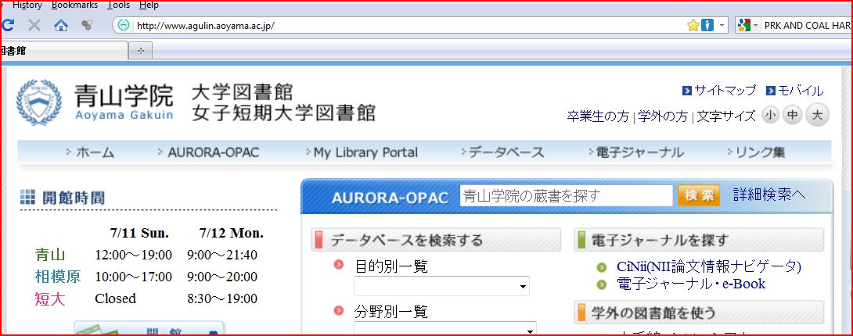

- Click on 「データベース」. On the menu bar, it is the fourth item from left margin.
Next, you will see a screen like that reproduced below. Some databases are available at the Shibuya Campus, some of them at the Sagamihara Campus, and others at the junior college, and some from your home.

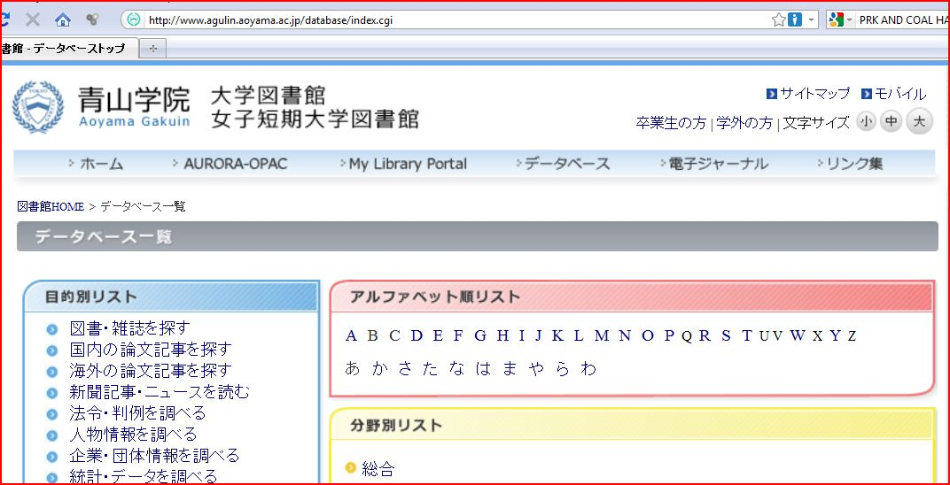

- Click on any of the letters of the alphabet under 「アルファベット順」. Then, an alphabetical listing of all the available databases will appear on the right. You’ll find the following ones especially useful:

* Academic Search Elite Library (EBSCOhost)
* Communication & Mass Media Complete (EBSCOhost)
* EBSCOhost
* Linguistics and Language Behavior Abstracts
* OED online
* ProQuest Central
* TESOL Quarterly (only available at the Shibuya Campus)
[All of the ones on the list are available from your home computer, except for TESOL Quarterly.]

- Click on “P,” then the name of a database, for example, ProQuest Central which contains ProQuest Newspapers and Dissertations & Theses and you will be prompted for your ID and password.

- Your ID is your faculty ID number. When working on campus, you should put down the full number exactly as it appears on your card, (ie. 000189). However, if you are accessing the database from your home or another off campus location, then replace the first “0” with a small letter “t.”
You will already have a password if you have been using a CALL room this year. Some teachers have created passwords based on their date of birth. Therefore, if their birthday is April 6, 1960, their password would be “19600406.” You can create a password or reset your password by going to the Computing Office, 4F, B Building. They will assist you in logging on and making a new password.

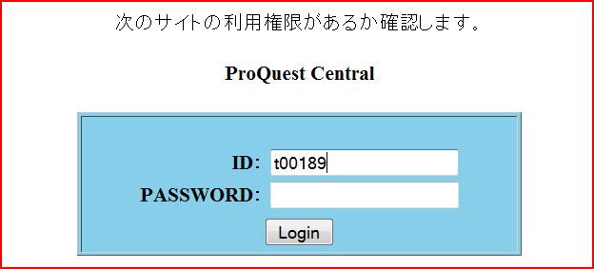

Each database has its own unique search interface. Each of the databases have similar dialog boxes into which you will need to type a “search term.” The more specific and focused your search term, the better your search results will be. Most of them contain a button on the toolbar to switch languages. For example, the one for EBSCO HOST looks like this:

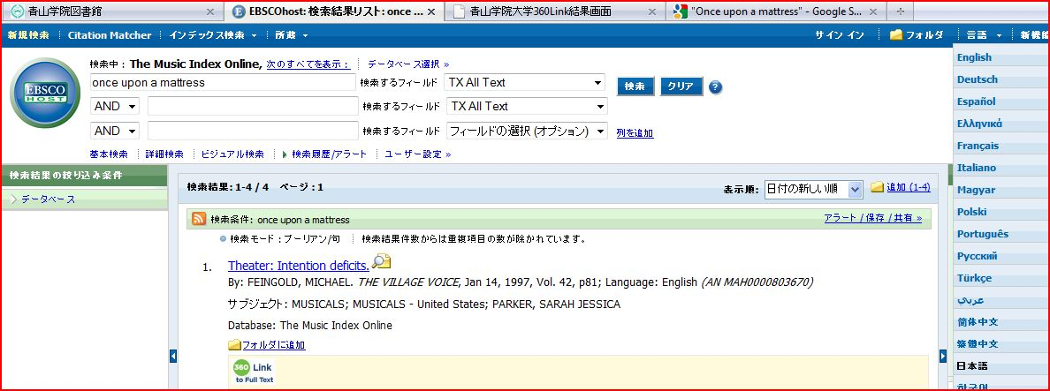

When you use ProQuest, you will be asked to choose which newspapers or periodicals to search. The next screen for ProQuest looks like this:

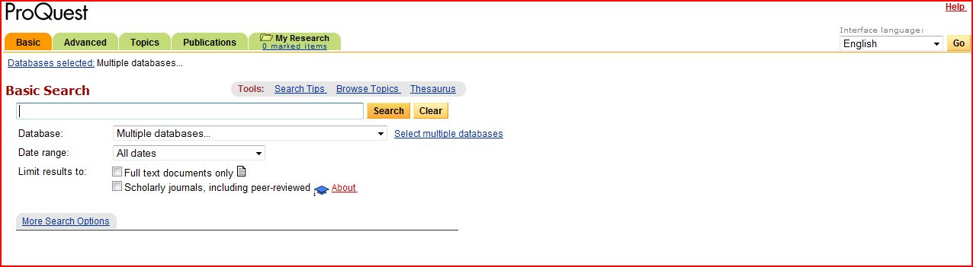

- Some of the articles are available in their entirety. If the entire article can be accessed, you will see 「PDF全文」or 「HTML全文」under it. Clicking on those links will allow you to download the complete text of the article.

NOTE: The method that students use for accessing the database is slightly different than that of teachers. They will be prompted for their user ID and password. The user name should be their student ID number with an “a” preceding it. The password should be their date of birth; if their birthday is April 6, 1985, the password would be “19850406.”

In terms of EBSCOhost and JSTOR databases, page 44 of the student booklet contains an activity on their use. The answers to it are as follows.

1)Legal Language: Pragmatics, Poetics, and Social Power
Elizabeth Mertz
Annual Review of Anthropology, Vol. 23, (1994), pp. 435-455

2)Freedom and Tradition in the Kabuki Actor's Art
Leonard C. Pronko
Educational Theatre Journal, Vol. 21, No. 2 (May, 1969), pp. 139-146

3)Theories and Politics in African American English
Marcyliena Morgan
Annual Review of Anthropology, Vol. 23, (1994), pp. 325-345

4)Trends in Recent American Fiction
Howard M. Harper, Jr.
Contemporary Literature, Vol. 12, No. 2 (Spring, 1971), pp. 204-229

4)Visual Rhetoric in Advertising: Text-Interpretive, Experimental, and Reader-Response Analyses
Edward F. McQuarrie, David Glen Mick
The Journal of Consumer Research, Vol. 26, No. 1 (Jun., 1999), pp. 37-54

I.(h) YOUR CLASS AS A WRITING COMMUNITY
As much as possible, use peer editing and peer response with your students. This will encourage them to view writing as a process of You may also wish to have your students post their essays for other classmates to read and comment upon.

You can set up peer exchanges outside of class as well through using e-mail and student partners, or through creating a class blog site (ie. https://www.blogger.com). As much as possible, you should accustom your students to reviewing their writing with partners and in small groups. These measures will improve their work, their recognition of their mistakes, and reduce the number of errors you have to correct.

You can set up peer exchanges outside of class as well through using e-mail and student partners. As much as possible, you should accustom your students to reviewing their writing with partners and in small groups of other students. These measures will improve their work, their recognition of their mistakes, and reduce the number of errors you have to correct in their work.

II. TEACHING THE MLA STYLE
Both APA and MLA are used in the English department. But more professors use the MLA Style. So, rather than try to teach both, we have chosen to teach the MLA Style.
It more commonly associated with Literature and the Humanities than APA. We introduce the MLA Style in IE Writing II, and emphasized it further with the book reports and media and newspaper discussions in the IE II and III Core classes.

Refer students to the Academic Writing Students Booklet to see the main aspects of it. In class, if you have computer access, demonstrate the use of the following websites. They have been shown this in other classes, so this is a review. Assign your students, some practice examples for homework:
1) http://citationmachine.net/index2.php
2) http://www.easybib.com/
THE EXAMPLES ARE ALSO SHOWN P.15 OF THE 2014 AW STUDENTS’ BOOK.

Just input the information and choose MLA, APA or Chicago.
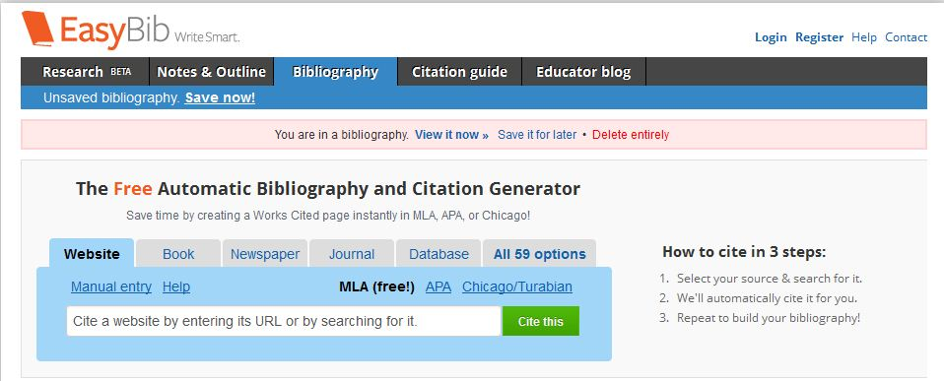
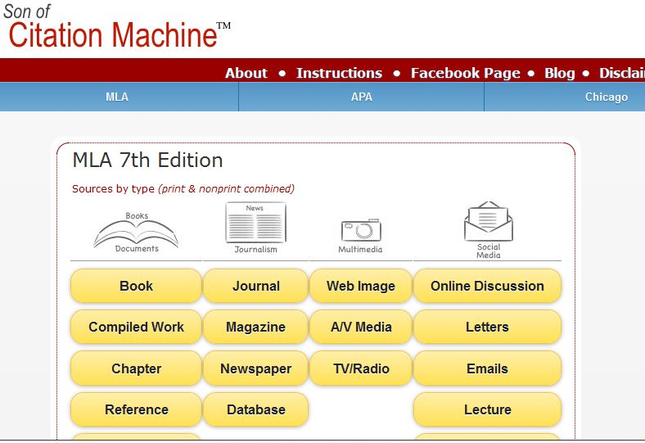
The student booklet for the Academic Writing course includes numerous examples of website citations, so there is no need to repeat that information in these teachers’ notes. There are some general principles, however, for electronic references for you to teach:
a) Single space between lines; double space between entries. Indent every line
after the first;
b) Omit the elements that are irrelevant or unavailable;
c) When page numbers are not available to identify part of an electronic document, use chapter or section information;
d) When a document consists of multiple pages or sites, provide the URL of whatever page provides easiest access to all of them (ie. the home page).
Earlier in this guide, there were references in the Critical Thinking and on evaluating the reliability of websites. Additional information about citing electronic sources can be found at the Modern Languages website and the following Internet sites.

http://www.bedfordstmartins.com/online/cite5.html
http://www.citationmachine.net/
http://dianahacker.com/resdoc/p04_c08_o.html

http://honolulu.hawaii.edu/legacylib/mlahcc.html
http://www.lib.berkeley.edu/MRC/mla.html
http://library.osu.edu/sites/guides/mlagd.php
http://kclibrary.nhmccd.edu/mlastyle.htm

http://www.mla.org/publications/style/style_faq/style_faq4
http://www.smccd.net/accounts/webready/lesson9_mla-check.asp

Here are some examples of electronic references, drawn from those on the website of the University of Pennsylvania Library. These are also in the student guide book.
There will be some instances (ie. multi-author CD rom) where you may be hard pressed to find the right form because it is different from any of these examples. While it is important to get the MLA format correct, the principle behind citations and references is to accustom students to doing research and to citing their sources.

II.(a) CITING ELECTRONIC RESOURCES
Author Family Name, First Name (If no Author is given, alphabeticize by the Title). “Title” or description such as ‘homepage.’ Date of electronic publication, name of database or online services. Pages, paragraphs or sections used. Name of any institution affiliated with the web page. Date of access <URL>.

a) Electronic book
Tucker, Karen B. Westerfield. American Methodist Worship. New York: Oxford UP,
2001. 2 Dec. 2001. <http://digital.library.upenn.edu/ebooks/pdfs/019512698X.
pdf>.

b) From e-journals
Janssen, Maarten C. "On the Principle of Coordination." v, 17.2 (2001). 29 Nov. 2001.
<http://www.journals.cambridge.org/>.

c) From EBSCOhost (a service to which AGU library subscribes offering
numerous databases)
Jeffrey, Robert W., and Simone A. French. “Epidemic Obesity in the United States: Are
Fast Foods and Television Viewing Contributing?” American Journal of Public Health 88.2 (1998): 277-81. Business Source Premier. EBSCOhost.
Aoyama Gakuin University Library, Tokyo. 17 July, 2009.

d) From full-text databases
Gourevitch, Victor. "Rousseau on Providence." The Review of Metaphysics. (Mar.
2000). Expanded Academic ASAP. Gale Group. University of
Pennsylvania Library, Philadelphia. 2 Dec. 2001. <http://web7. infotrac.
galegroup.com/itw/infomark/429/324/18810857w7/purl=rc1_EAIM_0_A7069 645
4&dyn=4!xrn_9_0_A70696454?sw_aep=upenn_main>.

e) From online newspapers
Wilford, John Noble. "Artifacts in Africa Suggest an Earlier Modern Human." New
York Times on the Web 2 Dec. 2001. University of Pennsylvania Library,
Philadelphia 4 Dec. 2001. <http://www.nytimes.com/2001/12/02/science/
social/02BONE.html>.

f) From full-text databases
Wilford, John Noble. "Artifacts in Africa Suggest an Earlier Modern Human." New York Times 2 Dec. 2001. Lexis-Nexis Academic Universe, 4 Dec. 001.
<http://web.lexis-nexis .com/universe>.

g) Electronic book
Tucker, Karen B. Westerfield. American Methodist Worship. New York: Oxford UP, 2001. 2 Dec. 2001. <http://digital.library.upenn.edu/ebooks/pdfs/
019512698X.pdf>.

“In Text Citations.” Penn Online Research Tutorial. 30 July 2004. University of Pennsylvania, Library. <http://gethelp.library.upenn. edu/ PORT/ Port7c.intextMLA.html>.

II.(b) IN-TEXT CITATIONS
This is a very technical aspect of academic essay writing, so please ensure that your students understand how to do it. MLA Style requires that you identify the location of any cited information as precisely as possible in brackets. This reference consists of the author’s name, or is placed at the end of the quotation in brackets.

Unfortunately, Internet sources rarely come with page numbers, so instead of using page numbers, note any internal divisions in the url.

Herrington, TyAnna K. “Being is Believing.” Rev of Being Digital, by Nicholas
Negropointe. Kairos: A journal for Teaching Writing in Webbed
Environments 1.1 (1966) at “Reviews.” 24 May 1996
<http://english.ttu.edu/kairos/1.1.>

Each quotation will also need a transition phrase to introduce it. Again, the material is drawn from the website of the University of Pennsylvania Library.

a) Work by a single author
Several rivers aside from the Thames once intersected London, but they have since been covered by the city (Clayton 28).

b) Work by a single author named in the text
Antony Clayton points out that several rivers other than the Thames once intersected London, but they have since been covered by the city (28).

c) Work by two authors
The unemployed men and women in Denmark have had the right to request job-related activities such as training, but recently this has become an obligation (Rosdahl and Weise 160).

d) Work by three or more authors
Cite all authors the first time the reference occurs; in subsequent citations, include
only the last name of the first author follow by et al.

e) Electronic Sources
Electronic sources are cited in the typical author-page number style with one
difference: when an Internet site does not have page numbers, offer other location
information such as screen or paragraph (par.) number.

Because of Greece's physical characteristics – a jagged coast made almost all settlements within 40 miles of the sea-- the ancient Greeks relied on the sea for most long-distance traveling (Martin sec. 2.4).

f) Multivolume Works
Most of Plato's ideas about love are recorded in the Symposium (Singer 1: 48) while Ficino's are in the Commentary on Plato's Symposium (Singer 2: 168).

g) Works by corporate authors
Between 1970 and 1994, expenditures on information processing equipment rose at an annual rate of 9.7 percent (Natl. Research Council 25).

h) Indirect quotations
Use this form to cite a quotation that was identified by its being a quotation in
another (not the original) source.

John Evelyn described London's churchyards as being filled with bodies "one above the other, to the very top of the walls, and some above the walls" (qtd. in Clayton 14).

i) Classic Literary and Religious Works
When citing a classic work that is available in multiple editions, try to provide
location information (chapter, section, verse, etc.) beyond the page number.

Wittgenstein writes, "the philosopher's treatment of a question is like the
treatment of an illness" (Wittgenstein 91: sec. 255).”

When citing plays, poems or the bible, omit page numbers and cite by
division (act, scene, canto, book, part, etc.) and line.

Queen Gertrude is concerned about Hamlet's great distress over his father's
death, saying "Do not for ever with thy vailed lids / seeks for they noble father in
the dust: / thou know'st 'tis common; all that lives must die..." (Ham. 1.2.70-72).

Works Cited:
“In Text Citations.” Penn Online Research Tutorial. 30 July 2004. University of Pennsylvania, Library. <http://gethelp.library.upenn.edu/
PORT/Port7c.intextMLA.html>.

SAMPLE ESSAY:
Examples of MLA used with bibliographies, in-text citations, and an entire essay written with the MLA style can be found at…http://dianahacker.com/resdoc/p04_c08_o.html

SIX COMMON MISTAKES IN STUDENT ESSAY CITATIONS:

- Using all CAPITAL letters for a book or journal title.
- Forgetting to indent the 2nd line of the bibliographic item.

- Missing periods, especially after the <url>.
- Failing to reformat the <url> to change it from an underlined hyperlink.
- Missing dates.
- Omitting the most recent printing of a book.

III. ADDRESSING PLAGIARISM
For a number of reasons, including inexperience in writing essays, students plagiarize (tosaku, the noun, and hyosetsu suru, the verb form) material from other sources. Appropriately enough, the term “plagiarize” is derived from the Latin word for “kidnapping.”

We have to address the issue in a number of ways, including (a) teaching them the concept of plagiarism and fair use, (b) good note-taking from source materials, (c) the proper use of quotations, (d) paraphrasing and summarizing materials, (e) .

Drawing on the work on the work of Carroll (2000), Culwin and Lancaster (2001), Evans (2000), and Gibelman, Gelman, and Fast (1999), the University of Melbourne has listed 36 different strategies to minimize plagiarism. Altogether, they form a three-point plan:

- Make your expectations clear to your students.

- Design your assignments in such a way as to minimize the opportunities for plagiarism, and breaking the essay up into smaller assignments.

- Monitor, detect, and swiftly respond to incidents of plagiarism.

The 36 strategies include:
- Review the skills of summarizing and paraphrasing.
- Teach students how to build an argument.
- Teach the skills of referencing and citation.
- Include mini-assignments (check in the student booklet) in creating a bibliography, thesis writing, preparing notes, etc. in the essay assignment.
- Ask students to make brief presentations (check in the student booklet for details on assessment) to the rest of the class.
- Ask students to hand in an annotated bibliography or notecards before the assignment is due.
- Ask students to do a short self-reflection paper, ie. “What did you learn from this assignment?”
or “What problems did you encounter and how did you overcome them?”
- Demonstrate a search engine in class to identify the sites that students are likely to find and plagiarize.
- Demonstrate to students your awareness of electronic search engines and how easy it is to detect examples of plagiarism.

III.(a) DEFINING PLAGIARISM
Begin with explaining the kind of information that there is no need to document, statements of fact such as the current Prime Minister of Japan or that the 2010 Winter Olympics were held in Whistler, Canada. A simple rule of thumb for students is that any numbers, or specialized information that they couldn’t know must be referenced. Proverbs or well-known quotations need not be referenced.

1. Review the rules with students. Show clear examples of plagiarism and of
appropriately acknowledged sources that have been referenced by page. But if showing work from a student in the class, conceal the student’s name. The point is not to humiliate students publicly but to ensure that the class is aware that plagiarism is easily detected and is a serious matter.

In addition, examples of paraphrases should be shown as well. See the
Exercises on page 45 in the appendix of the student guide for exercises in
developing paraphrases.

The following table is included in the student booklet.

Document Your References | Fair Use
1. When you quote someone else’s  words, or even ideas,  paraphrase or summarize them from any book, interview,  newspaper, radio broadcast,  software, TV program,  or website  2. When you copy any statistics, or  graphic | - When you reach some original conclusion or describe a personal experience  2. When you write about  something commonly known or at least well known in your field of study

III.(b) DETECTING PLAGIARISM
The most elementary means of detection. First of all, there is your knowledge of your students and their relative abilities. Often, weaker students, or those with frequent absences from Academic Writing panic and hand in plagiarised papers. Like most of the plagiarised papers that we see, there are passages in paper, rather than the whole paper that is plagiarised.

You can usually find a plagiarised paper through a close reading of it. If it is almost error-free, or contains completely error-free passages, complex grammatical constructions far above the student’s ability, and/or contains unusual vocabulary of archaisms, it is usually copied.

Secondly, you can check for plagiarism by pasting suspected sentences into the search box of “Google” and it will often direct you to the site where students have gotten the material. This works very well with checking book reports for plagiarism in the IE Core classes of the IE Program. It also works for much of the “copy-and-paste” plagiarism that we see in IE Writing II, III, and Academic Writing.

For further advice on detecting plagiarism by using the Wed, refer to http://marywood.edu/library/detectplag.htm

A very common type of student plagiarism is simply a failure to properly cite
references, often due to inexperience in writing essays, and in using quotations.
Therefore, frequent examples discussed in class, and in-class writing activities
are of great use.

III. (c) USING QUOTATIONS
There are a number of exercises in the student guide on quotations, so some general guidelines are all that will be covered here. First of all, students often translate quotations from Japanese into English and use them as direct quotations. They are not direct quotations, but technically would have to be handled as paraphrased quotations with appropriate transitions and page references.

Few of our students do these translations very well; some go as far as translating sentences and whole paragraphs by using online translation software which is comically inaccurate.

http://www.worldlingo.com/wl/mstranslate/UP26384/T1/P2/l/

You might try this yourself by asking your students to translate an English sentence into Japanese, then showing them the machine-translated version, and then finishing off by translating it back to English. This will show them the ridiculous results. An example is included in the Academic Writing Student Guide.

Direct students to record the quotations they plan to use onto note cards. This will force them to introduce a further step into their writing process. The note cards can be checked against their essays later as well for an in-class quoting and summarizing activity.

III.(d) PARAPHRASING AND SUMMARIZING
These two terms are often used inter-changeably in most writing texts. We would appreciate if you could make a teachable distinction for the students between paraphrase for phrases and summaries for larger blocks of text such as paragraphs or page-length content.

As well, choose summarizing activities where the students have to render large
blocks of text into a few very concise sentences.

1. One very good suggestion for teaching paraphrases is to show students an OHC projection of a sentence. Allow them to discuss it with a partner. (This well help ensure that they understand it). Then require them to do a paraphrase from memory.

- Next, you check their version against the original for content, accuracy, and
mistakenly plagiarized phrases; they can, of course, include exact phrases,
but these must be identified with quotation marks and referenced.

III.(e) NOTE-TAKING
The best way to get your students to avoid plagiarizing their sources is to start with classroom exercises in which they carefully take notes of a source. Next, assign them some note-taking from one of their sources. This could then be checked in the following class against the original source.

I. Note Cards
Note cards can be used in the course to encourage your students to record their direct quotations, paraphrases, and summaries. Note cards are a very effective way of dealing with plagiarism because they promote more planning of the essay. You could collect them from students in advance of a first draft and therefore promote better planning, or you might ask for them at the end of the process though some students may simply produce the note cards after they have written the essay.

These note cards are usually small cards about 7cm by 12cm in size and note the “author” of the material as well as “the page number” from which the material was collected. The author and page number should be put on the top of the card. The students don’t need to put down publishing information because they will already have that information in their bibliographies.

On the rest of the card, they should record direct quotations from their sources. They might also put down any paraphrases or summaries of their references.

III.(f) STRATEGIES TO AVOID PLAGIARISM IN
QUOTATIONS
Teach your students to avoid using key adjectives and phrases such as the ones in bold type in the text if they are paraphrasing a quotation. Of course, the underlined words are essential in using this quote, so students would be best advised to simply use quotation marks.

Original (In Vancouver Sun)
Four years after she won five gold medals and set two world records at the 2000 Sydney Paralympics as a precocious 16-year old, Swimmer Stephanie Dixon swam faster in all her events in Athens – and came home with just one gold medal.

Other strategies:
1. Vary your signal phrases—
a) As Gary Kingston has noted…
b) Gary Kingston emphasizes…
Use the verb that best fits the sentence: admits, argues, analyzes, believes, concedes, endorses, points out, questions, refutes, rejects, reports, states, writes-

- Use only quoted phrases instead of a whole sentence. Again, there are
exercises in the student booklet, from pages

According to Gary Kingston, in the 2000 Sydney Paralympics, Canadian swimmer Stephanie Dixon won “five gold medals” and she made “two world records” while only sixteen years old. But at the next Paralympics, even though she swam faster, she only won a single gold medal (Kingston, p. E1, 2008).

Work Cited:
Kingston, G. “Paralympics: Canadian Athletes Aren’t Discouraged That Their Medal Total May Drop in Beijing.” Vancouver Sun. (2008). E1.

IV. CLASSROOM ACTIVITIES
The Academic Writing classroom is supposed to be an active one, not one where the students quietly sit doing their homework while the teacher sits at the front of the class and grades papers. Neither should it be one in which groups of students led by the able writers among them produce a "group essay."

Furthermore, resist the temptation to excuse some students from class while you conference with others. Instead, organize your class in such a way that students always have something writing to do: brainstorming, drafting, rewriting, responding to each other’s work, or time in which they prepare for their presentations. You should organize different work groups for this purpose.

You should be directing a writing workshop. Sometimes, this means inter-acting with small groups of students.

At other times, you will be directing the whole class, explaining the structure of an essay, organizing a writing game, perhaps using an overhead project to analyse typical student errors.

Games also are a very effective way to interest students in writing. As well, games offer opportunities for students to teach one another about writing. Finally, they help develop a sense of community among the students in your class.

Games are easily created by (a)giving students writing problems to solve within set time limits, (b)creating competitions around writing activities, (c)making the writing process part of a communicative activity.

Depending on how the writing tasks are introduced, games can provide students with a hands-on-manipulation of the language. As well, games can help students understand the difference between writing modes. Some of the many possible activities in your class are listed below:

1. Small group activities of two or three students, reacting to and making suggestions regarding a paper (perhaps a rough draft) produced by a third student.

2. Composing-on-the-board, with volunteers making attempts to solve a given writing problem on the blackboard, for example, reworking part of a paper by a classmate.

3. Whole class discussions of one, two, or three photocopied papers produced by class members, (the writers of the papers should remain anonymous).

- Conferencing, the teacher circulating about the class to help
individuals with writing problems while the other members of the
class work in groups on their papers.

5. Editing lessons for the whole class, dealing with a limited problem that all have in common.

6. Sentence combining problems where teams of students compete in rewriting short, simple sentences into longer, complex ones where there is a use of coordinate and subordinate conjunctions. (See the exercises on page 36 of the Appendix of Academic Writing student booklet).

- Exercises for expanding and developing paragraphs or thesis
statements involving the entire class or groups of students.

8. Class discussion of the audience for a paper, and then adjusting the paper for that audience.

9. Critical discussion of a reading -- How did the author get this effect? What are the transitions?

10. Sample essay exam questions for reading, analyzing, and answering.

- Language games, such as the "round-robin sentence," in which
students successively add adverbs or other modifiers to a base
sentence, or activities that emphasize transitions. Another game is
"sentence deletion" where students take turns reducing a sentence to its shortest, grammatical length.

- Paragraph cohesion games based on correctly ordering scrambled
sentences into a well-organized paragraph.

V. GRAMMATICAL ERRORS
Most research on teaching grammar to first and second language students is critical of the methods by which grammar is usually taught. Instead, the research conclusions focus on four main points.

1) Avoid teaching too much grammar through lecturing to the class and providing handouts. Grammar is best taught to your students within the context of each student’s writing.

2) However, certain points that might be new to the majority of your students such as the use of the semi-colon, or of subordinate conjunctions, for example, might be handled through a short lecture on their use, then classroom exercises. You might handle them through some group work or even a competition where students in small groups try to write the correct answers to questions on the board.

3) Correct student errors mostly on an individual/specific basis, dealing with each student’s errors through written comments on the student’s paper and a conference with them.

4) Whole-class lessons on errors might also come from notes you make after you have graded all your students’ essays and noted common errors.

After concealing the student’s names, you could then show some of these errors in a handout, on the OHC, or on the blackboard, then set the class to correcting them. They could work individually, and then again in groups, share them with the class, and then you could correct them again.

An excellent source for handouts on grammar is “OWL,” the online writing learning centre created by Purdue University. Of particular interest to our students and program are their English as a Second Language worksheets on adjectives and prepositions, and their Grammar, Punctuation, and Spelling worksheets which include one on sentence fragments. These are available as pdf files and can be easily printed.

http://owl.english.purdue.edu/handouts/print/index.html

VI. RESPONSES TO WRITING
It is not necessary to correct each piece of student writing, or each draft of their essay. There are other effective ways to deal with student errors first. Student checklists are an effective way, followed by peer evaluation n individual paragraphs, and the first draft of their essays.

Most Academic Writing teachers grade the shorter assignments such as the bibliography and the outline (as described in the “Steps” earlier in this guide). Then, they usually only respond in detail to two drafts of each student’s essay. These drafts whould be examined in late November and early December. The teacher grades the papers using the marking symbols on page 71 in the appendix of the student guide and which appear at the end of this guide.

- Afterward, tell your students to find and identify the errors. This leaves the problem-solving to them.

- Brief impromptu teacher-student conferences can be undertaken with individual students while the other students in the class are revising their papers. But please ensure that the other students are not merely waiting their turn. They should be revising their work or engaged in another assignment.

VI.(a) A PROTOCOL FOR CONFERENCING
Teacher-student writing conferences need a strong focus. Research indicates that students should feel that they have some control over the process.

If you simply comment on one of your student’s papers, then very often the student will nod, apparently agreeing, but afterward will make few successful revisions.

A more effective conference will include a more active role for the student.

A student conference should (1) be limited to 5 - 10 minutes at maximum, (2) focus on a complete early draft of the essay, (3) balance criticism of student work with praise, (4) incorporate student negotiation in the conference (through helping a student to formulate questions, and to confirm teacher remarks), (5) conclude with a student verbalizing what he or she will do next, and (6)finally, that teachers track the results of the meeting in terms of the student’s progress on the next draft.

The most straightforward approach to helping students formulate questions is to mark their papers with your marking symbols (on page 71in the Appendix of the Academic Writing Student Booklet and at the end of this guide), then ask them to review the symbols and your comments and to note any questions they have.

You might also use the Conferencing Form suggested by Joy Reid (1993) in which students answer questions about their essays before and after the conference. Afterwards, they revise their writing.

Conferencing Form:

1. I thought the best part of my essay was...

2. I thought the weakest part of my essay was...

3. According to your instructor’s comments:

Strengths: Weaknesses:
a) a)

b) b)

4. Based on the feedback, I will...

5. Three questions I want to ask are...

Work Cited:
Reid, J. Teaching ESL Writing. New York: Prentice and Hall, 1993, 222, 223.

VI.(b) RECORDED CONFERENCES
Recorded feedback is a very effective technique to use in conferencing. Hyland (1990) describes how minimal marking and taped commentary may create a very effective response to student writing. The teacher asks each student to access the recording function on their cell phone (ie. All iphones have this feature as do many other cell phones).

Recording your remarks helps the students a great deal in understanding them. Typically, students conferencing with their teacher will nod or express agreement, but forget or misunderstand your written remarks.

A recording of the conversation eases these problems. It is a major aid to
student revision. Students can listen to your comments later as many times as
they wish.

1. You pass the student papers back and ask the class to start finding and
correcting the mistakes on their papers.

2. Instruct them to circle any comments or symbols they don’t understand,
and ask each student to write down a question that they would like to ask you when they have their turn for a conference.

3. While you conference with one student, the other students in the class
are noting their questions or revising their essays.

By your modelling of feedback to students, recorded conferencing also encourage students to more critically assess their writing and that of their peers. The taping procedure is straightforward. The audio tape recording enables students to replay the conference for further clarification.

4. As each student-teacher conference begins, the teacher tests the tape.
5. While being recorded, the teacher asks the student to initiate the
conference with his or her three questions for the teacher (ie. “What would you like to ask me?” “Do you understand all my comments on your paper?” –Sometimes, students can’t read a teacher’s handwriting or don’t understand the point.) The teacher and the student discuss the student’s questions. Time allowing, the teacher might ask the student’s opinion as to the best and weakest parts of the writing. This might turn the discussion to one on the content, organization, or use of examples in the piece.

Not all these items will be discussed in every student-teacher conference. Some conferences with more skilled writers who have produced more polished and comprehensive drafts might be slightly less than 5 minutes; others, naturally will take longer. However, you should try to keep even the longest ones under 10 minutes, so that you can finish the conferences for a class of 25 within two successive class periods.

In the course evaluations since we began introducing these structured conferences, students often comment that they preferred conferencing and audio recordings to teacher conferences without the use of recordings, peer responses, or only written comments from the teacher.

VI.(c) MARKING SYMBOLS
Teachers most often respond to student papers with written comments or by correction of student errors. However, the comments are often hard for students to read or to understand. In addition, some researchers criticize error correction for its inconsistency. Others suggest that if teachers give students the answers, the students will never learn how to fix their errors.

A more effective response is to identify error types and to encourage students to focus on correcting these in their writing. The teacher circles or underlines all of a student’s errors or at least the representative ones and requires the student to correct them. Even if a teacher misses some of these grammatical errors, a student can still discern a pattern of error.

Teachers usually respond to student papers with written comments rather than by conferencing. But these same written comments can also be discussed and clarified during a student-teacher conference.

More effective responses in promoting student revision are to identify error types and to frame questions or requests for information to encourage students to develop their writing. The teacher circles or underlines all of a student’s errors or at least representative ones and requires the student to correct them.

This process starts with the teacher distributing a handout of the editing symbols (See the Appendix in the Academic Writing Student Booklet or p.41 of this teacher guide).

Most students will have been introduced to these same symbols in earlier IE Writing classes. We are trying to standardize them for the whole IE Program.

Each symbol identifies a writing error common to Japanese students and the handout includes a sentence with the error in it. Before returning your students’ papers, you might go over the error types and have students individually try correcting them, one by one. Afterward, students might compare their answers in pairs. Later, the teacher reviews the answers on the blackboard or OHC.

The teacher might also show examples of more substantive comments on a paper, such as those relating to content or essay organization.

For example, a flawed student essay comparing the Japanese and English languages might prompt the teacher to remark: “At this point, your thesis is not clear about which parts of the two languages you plan to compare.” The point of this part of the activity is to sensitize students to other kinds of writing errors they will make in the essay, errors related to organization and content, for example. Again, this activity is done using the blackboard or an OHC.

This activity could lead easily into a writing conference with each student. After the papers are returned to the students, each student reviews the comments on his or her paper and begins to correct them. Each student does this while waiting for a student-teacher conference. The students also use the class time to rewrite their papers. This activity of either revising or conferencing for a class of 25 students occupies most of the instructional time over a two-week period.

VI.(d) COMMENTING ONLINE
Using MS Word 2007, you can also highlight passages in a student’s paper, and add comments in the margin. It is even possible to leave audio comments, too.
VI. PRESENTATIONS
Because one function of the Academic Writing course is to prepare students for discussions and presentations on literature, linguistics, and communications in seminars in their third and fourth year classes, we ask Academic Writing teachers to have their students prepare a presentation. This activity takes about two classes to complete and also offers teachers some “breathing time” in between responding and marking the students’ essay drafts. You might schedule it in early December after collecting your students’ second draft. Alternately, you may wish to do it as a type of summative evaluation activity at the end of the course.

To run it most easily, assign one student in class to be the timekeeper. This will leave you free to watch and rate and write a note to the presenter and give the student immediate feedback after their presentation as well as cutting down on your marking.

Ideally, the students should practise making presentations in small groups. For faster-working students who may have already finished a written draft, this practice will allow them to present first.

Usually, they serve as good role models for the rest of the students. For further practice, students could be required to audio tape themselves so that they could review their efforts before their presentation. This pre-task approach will greatly improve their presentations.

A presentation should include:
a) an introduction to the research topic
b) a summary of the main points or topics
c) any surprising or interesting facts the writer discovered
d) comments on how the student felt after writing the essay
e) conclude with a personal view of the topic.

In addition, the presentation should be marked according to a set criteria and this criteria should be explained to students in advance. The best presentations are those in which students have prepared note cards, and rehearsed their speech. Some teachers even require their students to prepare a presentation in power point as well.

We have copies of videotaped Academic Writing presentations available for sign-out and a rating scale for these as well. Most teachers find that by viewing these with their students and rating them will give students a very good idea of the standards for this task.

The following scale is also included in the Academic Writing Student Booklet.

PRESENTATION /10 marks
1. Kept eye contact with your audience
2. Spoke freely, didn’t just read notes
3. Explained thesis clearly
4. Presented at least 3 topics
5. Gave examples for each topic.

VIII. A GRADING SCHEDULE
In order to evaluate your students accurately, and to encourage them to meet deadlines and to prepare adequately for class, you should give them a schedule and you should keep the following grading criteria in mind. The schedule should include homework assignments that are part of developing a research essay. This will prevent students from procrastinating on their essays. The remaining 5 marks might include class participation and attendance.

Due Date Points

Bibliography | 10
Thesis Statement and Outline | 15
Notecards and Quotations | 10
1st Draft for Peers | 15
2nd (Revised) Draft for Teacher | 15
3rd Draft | 15
Oral Presentation | 10
Participation and Homework | 5
Total

IX. ESSAY RATING SCALES
A number of years ago, we drew a series of marked essay samples drawn from students’ second drafts in Academic Writing. These papers were marked with a six-point scale based on the rating scales developed from the TWE (Test of Written English) and IELTS (International English Language Testing System).

Each step on the scale indicates a level of performance:
a) organization
- thesis statement
- topic sentences
- transitions
b) content
- use of examples
- quotations
- page references
- bibliography
- minimum of 1,500 words
c) structure
- sentence variety
- frequency of grammatical errors

The six samples of student writing were supposed to conform to the essay specifications in I. (c). Each one illustrates one of the 6 steps on the holistic marking scale which is reproduced here as well as in the student guide. Research indicates that the more experience students have in using a rating scale, the better they will become at assessing their own work. Sample student essays are also included in the student guide.

 | Organization | 1. Thesis - clearly stated, indicating topics to be developed  2. Topic sentences - appropriate, varied transitional phrases
6 | Content | 3. Paragraphs - developed examples, quotations, page references  4. Bibliography - 7 books, journals, websites, or newspapers  5. 2,000 word minimum content
 | Structure | 6. Sentences - frequent variations in sentence structure  7. Grammatical errors - few and not likely to impede communication
 | Organization | Missing two features of a “6" essay.
5 | Content | Missing two features of a “6" essay.
 | Structure | Missing two features of a “6" essay.
 | Organization | 1. Thesis - present but too general  2. Topic sentences - sometimes inappropriate or formulaic
4 | Content | 3. Paragraphs - some examples, but poorly explained  4. Bibliography - incomplete  5. Minimum of 2,000 words
 | Structure | 6. Sentences - a few variations in patterns  7. Grammatical errors - these occur often and block communication
 | Organization | Missing four features of a “6" essay.
3 | Content | Missing four features of a “6" essay.
 | Structure | Missing four features of a “6" essay.
 | Organization | 1. Thesis - undeveloped or inappropriate  2. Topic sentences - none or inappropriate
2 | Content | 3. Paragraphs - lacking quotations, page references and discussion  4. Bibliography - missing  5. Minimum of 2,000 words is not reached
 | Structure | 6. Sentences - no sentences are error-free  7. Grammatical errors - make it difficult to follow the writing
 | Organization | Minimal response
1 | Content | Minimal response
 | Structure | Minimal response

In the teacher marking sessions several years ago, the order of essays B, E was sometimes reversed so either order might be satisfactory. The correct order of the essays is as follows:

6 (B, E)
5 (E, B)
4 (D)
3 (C)
2 (F)
1 (A)

X. GROUP RATINGS
The package of essays that follow are included in the Academic Writing Student Booklet. They are intended to teach them about standards of writing performance. First, they should read and rate the essays for homework. In the following class, set them working in groups to decide on a group score for the essays. This makes the activity more communicative and provides a means for students to teach one another aspects of essay writing. During their discussion, they should refer to the features of each essay. After the group has decided on the score for each essay, a group member writes the scores on the board.

When all the groups have written their scores on the board, compare them, explaining what the right scoring was supposed to be and the reasons why some essays are weaker than others. The winning group is closest to the Academic Writing Teachers’ scores.

- Students read the essays, comment on them, and rate mark them for homework.

- The teacher checks the homework in class.

- The students compare their results in groups and decide on a group mark by convincing the other students to agree or disagree.

- As part of an in-class competition, groups compare their results, choose an answer for the group, then their group ratings on the board.

- Make sure that students have the essays correctly marked at the end of the activity, so that they can use them for reference when writing.

X.(a) TEACHER COMMENTS
6 | (B) | Though it is hard to find the thesis because the introductory paragraph is so long, the thesis, the last sentence in the introductory paragraph is a clearly stated comparison of John Irving and his fictional character, T.S. Garp. The paragraphs in the essay, well over 2000 words, are well-developed and include quotations and references. There is a bibliography, sentence variety, and few grammatical errors relative to the length of the essay and the complexity of the vocabulary.
5 | (E) | Not as much content, vocabulary, or sentence variety as essay B. More importantly, there are more frequent grammatical errors. However, all the other elements, the thesis, topic sentences, bibliography, and examples are present.
4 | (D) | Few variations in sentence patterns. The grammatical errors block communication.
3 | (C) | The thesis and topic sentences are not very clear. The transition (“Next”) are repetitious. There are many grammatical errors. The essay is less than 2,000 words.
2 | (F) | The thesis is very unclear and the topic sentences are sketchy, poorly constructed. The paragraphs lack cohesion and there are frequent grammatical errors. The student has done some research, however, and there is a partial bibliography although incorrectly done.
1 | (A) | No thesis, only one topic sentence. Only two paragraphs, far less than the 2,000 word minimum. Worse still, the choice of words and phrasing make it appear that the essay looks plagiarized from an encyclopedia, but as there are no references so it is hard to say where the source as the choice of words and sentences seem copied. There is no bibliography.

X.(b) STUDENT MODELS

Finally, some 5 outstanding student research essays ave been included in the student
guide. They are drawn from topics on literature and communication and illustrate
comparison and contrast among other genres. You should refer to them in class and
have student locate and underline thesis statements, transitions and topic sentences,
and the use of examples and quotations and their discussion.

XI. TEACHER RESOURCES
Some of these texts can be found in the English Department library.

Carroll, J. “Plagiarism: Is There a Virtual Solution?” Teaching News November 2000. 8 September 2008. <http://www.brookes.ac.uk/services/ocsd/2_learntch/plagiarism. html>.

Crowell, S., E. Kolba. The Essay. New York: Educational Design, 1990.

Culwin, F. & Lancaster, T. (2001). Plagiarism, Prevention, Deterrence & Detection. Institute for Learning and Teaching in Higher Education, South Bank University, U.K. 8 September 2008 <http://www.ilt.ac.uk/resources/Culwin-Lancaster.htm>.
Evans, J. The new plagiarism in higher education: From selection to reflection. Interactions 4 (2). 2000, 6 August, 2006. 8 September 2008
<http://www.warwick.ac.uk/ETS/interactions/Vol4no2/evans.htm.>
Gibelman, M., Gelman, S. R., & Fast, J. (1999). The downside of cyberspace: Cheating made easy. Journal of Social Work Education 35 (3), 367-376.

Frydenberg, Gro, & Cynthia A. Boardman. You're In Charge: Writing to Communicate.
Reading, Mass: Addison-Wesley, 1990.

Hyland, K. (1990). “Producing Productive Feedback.” ELT Journal, 44, 4, 279-285.

Kingston, G. “Paralympics: Canadian Athletes Aren’t Discouraged That Their
Medal Total May Drop in Beijing.” Vancouver Sun, 2008, E1.

Oshima, A., & Hogue, A. Writing Academic English. 4th ed. White Plains, New
York: Addison Wesley Longman, 2006.

Raimes, Ann. Techniques in Teaching Writing. UK: Oxford University Press, 1983.

Reid, Joy. The Process of Composition. New York: Prentice-Hall, 1988.

Reid, Joy. Teaching ESL Writing. New York: Prentice-Hall, 1993.

XI.(a) FURTHER REFERENCES
Ferris, D. “Student Reactions to Teacher Response in Multiple-Draft
Composition Classrooms,” TESOL Quarterly 29, 1995: 33-52.

Ferris, D. “The Influence of Teacher Commentary on Student Revision,”
TESOLQuarterly 31, 1997: 315-339.

Ferris, D. “Teaching Writing for Academic Purposes.” Ed. J. Flowerdew,
M. Peacock. Research Perspectives in English for Academic Purposes.
Cambridge: Cambridge University Press, 2001. 331-346.

Hillocks, Jr., George. Research on Written Composition: New directions for
Teaching. Urbana, IL: National Council for Research in English: ERIC, 1986.

Kitagawa, M., & C. Kitagawa. Making Connections with Writing: An Expressive Writing
Model in Japanese Schools. Portsmouth, NH: Heinemann, 1987.

Raimes, A. "Out of the Woods: Emerging Traditions in the Teaching of Writing."
TESOL Quarterly 25, (1991): 407-430.
XII. MARK-UP SYMBOLS
A? Article missing He is __A?__ tallest boy in the class.
WA
WA Wrong article He gave me a advice.
C

C Capitalization She was a politician in japan.
FRAG
FRAG Fragment Because there are many problems.
K/L
K/L Confusion over I hope to know about it.
know and learn
P
P Punctuation Some plants can move _Most cannot move.
Pl
Pl Plural These story are translated.
PREP
PREP Preposition She is very kind ___ children.
WPREP
WPREP Wrong preposition He is excellent to sports.
PRON
PRON Missing pronoun She bought the book, so it is book.
WPRO
WPRO Wrong pronoun She bought the book, so it is his book.
REP
REP Repetition Scientists do scientists' work, scientifically.
ROS
ROS Run-on-sentence Everybody talks, nobody listens.
SP
SP Spelling He lives in Canda.
SVA
SVA Subject/verb The men in the factory works hard.
T
T Wrong tense I watch the film last night.
V
V Verb missing He a fat man.
WV
WV Wrong verb form Tea is grow in India and Japan.
WO
WO Word order Can you tell me the station is where?

