I. (f) ACCESSING AGU’s ONLINE DATABASES
Demonstrate to students how they can access journal articles through the AGU Library database of electronic resources. Please use the database for your private research and familiarize yourself with it. To use the database, follow these steps:

- Go to AGU Library’s home page: http://www.agulin.aoyama.ac.jp/

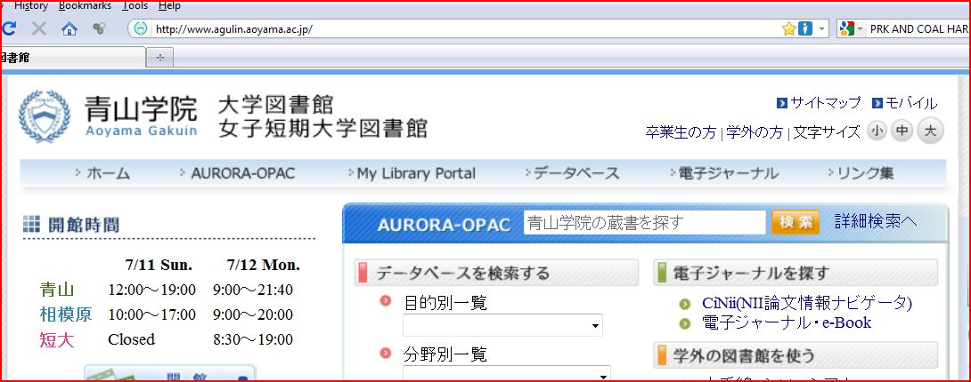

- Click on 「データベース」. On the menu bar, it is the fourth item from left margin.
Next, you will see a screen like that reproduced below. Some databases are available at the Shibuya Campus, some of them at the Sagamihara Campus, and others at the junior college, and some from your home.

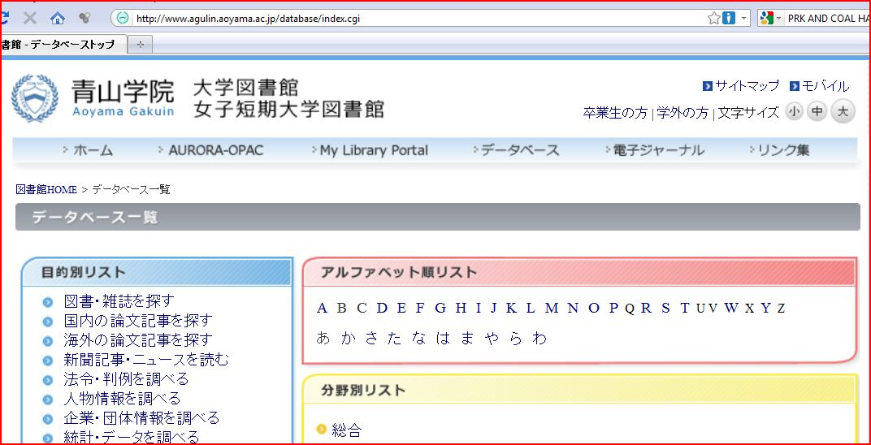

- Click on any of the letters of the alphabet under 「アルファベット順」. Then, an alphabetical listing of all the available databases will appear on the right. You’ll find the following ones especially useful:

* Academic Search Elite Library (EBSCOhost)
* Communication & Mass Media Complete (EBSCOhost)
* EBSCOhost
* Linguistics and Language Behavior Abstracts
* OED online
* ProQuest Central
* TESOL Quarterly (only available at the Shibuya Campus)
[All of the ones on the list are available from your home computer, except for TESOL Quarterly.]

- Click on “P,” then the name of a database, for example, ProQuest Central which contains ProQuest Newspapers and Dissertations & Theses and you will be prompted for your ID and password.

- Your ID is your faculty ID number. When working on campus, you should put down the full number exactly as it appears on your card, (ie. 000189). However, if you are accessing the database from your home or another off campus location, then replace the first “0” with a small letter “t.”
You will already have a password if you have been using a CALL room this year. Some teachers have created passwords based on their date of birth. Therefore, if their birthday is April 6, 1960, their password would be “19600406.” You can create a password or reset your password by going to the Computing Office, 4F, B Building. They will assist you in logging on and making a new password.

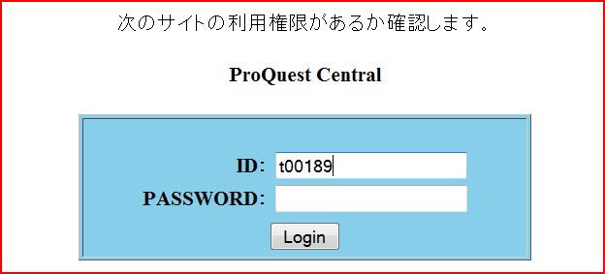

Each database has its own unique search interface. Each of the databases have similar dialog boxes into which you will need to type a “search term.” The more specific and focused your search term, the better your search results will be. Most of them contain a button on the toolbar to switch languages. For example, the one for EBSCO HOST looks like this:

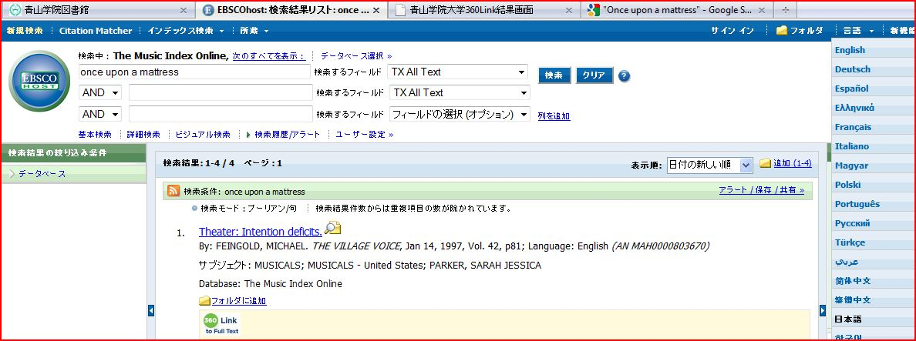

When you use ProQuest, you will be asked to choose which newspapers or periodicals to search. The next screen for ProQuest looks like this:

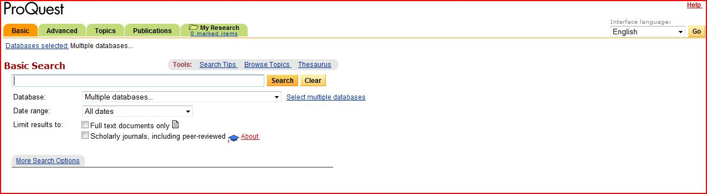

- Some of the articles are available in their entirety. If the entire article can be accessed, you will see 「PDF全文」or 「HTML全文」under it. Clicking on those links will allow you to download the complete text of the article.

NOTE: The method students use for accessing the database is slightly different than that of teachers. After they click on the button「こちらから入ってください」, they will be prompted for their user ID and password. The user name should be their student ID number (just the number—WITHOUT a letter preceding it). The password should be their date of birth; if their birthday is April 6, 1985, the password would be “19850406.”

In terms of EBSCOhost and JSTOR databases, page 44 of the student booklet contains an activity on their use. The answers to it are as follows.

1)Legal Language: Pragmatics, Poetics, and Social Power
Elizabeth Mertz
Annual Review of Anthropology, Vol. 23, (1994), pp. 435-455

Freedom and Tradition in the Kabuki Actor's Art
Leonard C. Pronko
Educational Theatre Journal, Vol. 21, No. 2 (May, 1969), pp. 139-146

2)Theories and Politics in African American English
Marcyliena Morgan
Annual Review of Anthropology, Vol. 23, (1994), pp. 325-345

3)Trends in Recent American Fiction
Howard M. Harper, Jr.
Contemporary Literature, Vol. 12, No. 2 (Spring, 1971), pp. 204-229

4)Visual Rhetoric in Advertising: Text-Interpretive, Experimental, and Reader-Response Analyses
Edward F. McQuarrie, David Glen Mick
The Journal of Consumer Research, Vol. 26, No. 1 (Jun., 1999), pp. 37-54

