CE 1, 2, 3

APPENDIXES

APPENDIX 1
CE 1, 2, 3: GROUP DISCUSSIONS
Teaching discussion skills begins in CE 1 with a discussion based on a Japanese newspaper, Japanese TV news program, or one of the simplified news broadcasts or articles shown later in Appendix 1#. These same skills will be used in CE 2 and 3, but you should expect the students to read and summarize and comment upon longer, more difficult articles, and for students to write solely on English newspaper articles in CE 3.

You also need to teach students the fundamentals of leading an effective group discussion: using names when addressing other group members, incorporating appropriate turn-taking language and questioning, including follow-up questions, and integrating such non-verbal communication into the discussion as making eye contact while speaking, and using gestures. In addition, students must learn certain idiomatic phrases to solicit opinions, to take turns while speaking, to agree and disagree with one another, to ask for clarification and to make additional points.

In all three CE classes, students are to summarize news and to use a proper MLA citation for their summaries whether of a news broadcast or an article found on an internet new site. These summaries then become the focus for the discussions in class. The summary writing is very important because it will accustom students to using the MLA style, which they will be using later in their studies. The summary writing is also a good opportunity to teach the students how to avoid plagiarism.

CE 1 and CE2 students may submit Japanese articles; however, if they are using an English newspaper article, then they must attach the original newspaper to their summaries, then hand them in. A quick scan of an article after reading the summary will show you any portions that were plagiarized.

I.(a) INTRODUCING THE TASK: FIRST CLASS
In the first class, give the students a very short high-interest newspaper article with a large captioned photograph (the photograph and the caption are features that make it easier to comprehend newspaper articles). The students read it individually, find the key information, and compare this information with a partner. Individually, students prepare written summaries of about 10 sentences, and compare these in a small group, choosing the best one. These are shared with the class and evaluated by the teacher. In groups, students discuss their opinions and generate questions. This is the outline of the small group task.

After students understand the task, you should ask each student to sign up as a discussion leader for two times over the term. Use this list, circulated in class, as both a student contract, and as a basis for rotating the group leaders.

One important difference between the newspaper discussion in the first class and in subsequent classes is that each discussion group leader will circulate to five or six different groups. This is an essential part of the task.
The repetitions make it easier for the discussion leaders to describe their articles without reading from notes.

One final aspect of the task is that the discussion group leader should be recording some new vocabulary from the article and teaching it to his or her group. The leaders should be encouraged to choose about 5 key vocabulary words. These should be recorded on the paper handed in to the teacher.

I.(b) Teacher as Cheer leader
In preparing students to participate in a discussion and to serve as discussion group leaders, there are a number of steps to take. You must pre-teach the turn-taking and questioning language, and you need to show the students the sample discussions on DVD, and to get them to rate the discussion leaders that they see, so that they can internalize the performance standards.

During the discussion activity, you should circulate among the discussion groups correcting their language use.

While encouraging students to speak, you might correct their words or phrases by repeating them correctly to the students, or when necessary, correctly them explicitly.

You might comment on some of the things they say, modeling the kind of contributions you would like other students in the discussion group to make, and also showing that you can understand their points well enough to discuss them.

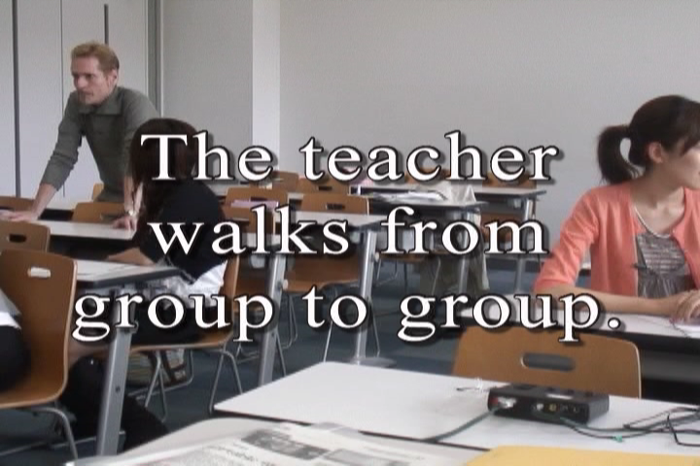 | 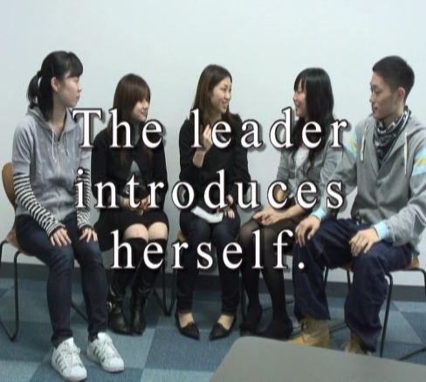 | 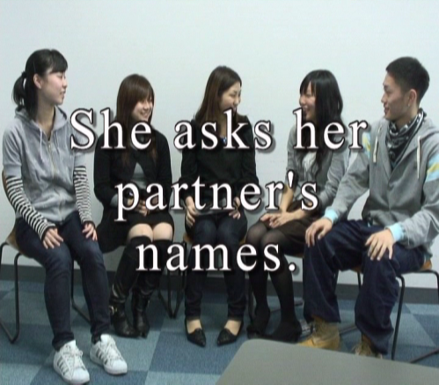

I.(c) INTERRUPTING, CLARIFYING
Numerous classroom activities can be undertaken. An example of one of them is a game to practice interrupting and asking for clarification:

1. The teacher or a student volunteer starts talking on any subject.

2. Anyone in the class can interrupt and disagree with the speaker or ask for clarification if they
use the right expressions.

3. The speaker quickly answers the person who interrupted or provides clarification and resumes
talking about the subject.
4. Everyone else keeps trying to interrupt or ask for clarification as often as possible and in as
many ways as possible to sidetrack the speaker.

I.(d) GIVING A REASON
Another is to practice adding reasons:

1. Get a small group of students to write down the names of different jobs on pieces of paper and
then fold over their papers so they remain unseen.

2. A group member draws a paper and reads it as if it were about the student sitting on the right:
"I think you would be a great singer because..."

3. The first group member passes the paper to the left and that person adds a different reason:
"Furthermore..."

4. Humorous or arbitrary reasons are acceptable, too.

5. When the paper has gone around, a new group member draws a second paper.

ASKING OPINIONS | AGREEING | DISAGREEING
What do you think?  What’s your opinion?  What’s your idea?  What do you have to say?  How do you feel about it?  Could you tell me...?  I’d like to ask...  I’d like to know...  I’m interested in... | I agree.  I have the same opinion.  I feel the same way.  Yes, this is what I think.  Likewise for me.  Certainly, that’s true.  Me too.  Likewise. | I disagree.  I can’t believe that.  I have a different opinion.  I have another idea.  I feel differently.  I don’t think so.  I can’t agree.
Figure 1# Turn-taking Language A

Once in groups, students brainstorm topics and determine the order in which each group member will serve as a discussion leader. The discussion leader is responsible for making some points about the subject of the discussion, asking other group members questions, and promoting discussion.
INTERRUPTING | CLARIFICATION | GIVING REASONS
Excuse me for interrupting, but...  May I say something?  Pardon me.  Sorry, but...  Wait a minute!  I might add here...  I’d like to say something… | Would you mind repeating that?  I didn’t catch the last part.  Sorry, I don’t follow you.  What was that?  I didn’t get that. | The main reason is...  Because...  Seeing as how...  This is the reason why...  That’s why...  Furthermore...  And another thing...

Figure 2# Turn-taking Language B

I.(e) ROUND ROBIN
In this exercise, a topic goes around the circle or small group and students either agree or disagree and offer a reason. Their reasons can be outrageous ones.

1. The world is really flat.
2. Santa Claus is a real person.
3. In fact, there is a rabbit making mochi on the moon.
4. The number four is unlucky.
5. All married men should try staying at home as homemakers in order to better appreciate their wives.
6. Your entire life has been a dream.

I.(f) SMALL GROUP MEDIA DISCUSSION TASK
Introduce the weekly task of the small group discussion task in the first class of the semester. Begin with (1) an explanation of the task parts, (2) showing your students the DVD samples of student discussions, (3) rating and discussing the samples with students, (4) doing a sample newspaper discussion in class.

Parts of the Small Group Media Discussion Task
Here are the steps to follow in the first CE 1, 2, 3 classes:

1. Show the students printouts of articles from online news sources like CNN (http://cnn.com) and the BBC
(http://bbc.co.uk), or from printed newspapers and magazines which they can find in the library, ie. The Japan
Times or The Daily Yomiuri. Once again, let them know that in CE 1 and CE 2, they can choose Japanese
newspapers, or TV news programs.

If possible, show them these newspapers online through using a connection in your room. Show them other
potential online news sources as well:
<http://www.asahi-net.or.jp/~gj7h-andr/index.files/news_english_online2.htm>
<http://www.cl.aoyama.ac.jp/~dias/EsllinksNewspapers.html>

If a student in your class has been abroad or is interested in visiting a particular city, then capitalize on that
interest and suggest that they find a newspaper from that place.
In the example of a newspaper summary in Appendix 2, a student, Tomomi Tsunoyama picked a newspaper
from the Gold Coast of Australia because she had lived there.

2. Demonstrate how the newspaper article summary is supposed to be done. Give the students photocopies or
print-outs of the article.

3. Have them note the source of publication information as completely as possible (writer, title of the article, name
of the newspaper or magazine, and date) according to MLA Style:
e.g., Park, Alice. “The Quest Resumes.” Time 9 Feb 2009: 30.

or an online newspaper article in which they must note the url, too:
e.g., Barrowclough, Anne. “Man Survives 180 Foot Plunge Over Niagara Falls.”

The Times Online. 12 April 2009. <http://www.timesonline.co.uk/tol/news/world/
us_and_americas/article5892498.ece>.

Remind them that they must capitalize the first letter of all the nouns and verbs in the title. Also, if the url of the
article is too long, that they break it into parts before and after the slash mark /. Have your students check their
work with each other. Most of the students will likely make errors in their notation. For an added incentive,
make the activity into a game by showing the students on the OHC or having them write it on the board.

4. Next, in point form, have them note the following key information:
Who? What? Where? When? Why? How?

Again, this can be compared in groups, or you could check by asking for answers from the class as a whole.

5. Have each students prepare a 10-line summary of the article by answering the W/H questions. Have your
students compare these in groups. Ask them to choose the best one and compare the best summaries on the
OHC. In this manner, you are teaching the students your criteria for assessing their efforts.

6. Have each group choose 5 vocabulary words that are important in the story, then write down a definition of
each of them and a sample sentence. Change your groups, so that each student moves to a new group to other
students the five vocabulary words.

7. Each student writes down an individual opinion (“I thought that...” or “I felt that...”).

8. Finally, each student should prepare 3 questions for the discussion. In groups, students should share their
opinions and ask their questions. Students follow this whole procedure in preparing for the discussion in which
they will be the group leader.

From the 2nd week, you should have your students practice turn-taking phrases in groups of three and four. When the class starts, you should have your students form into their groups and discuss their topics. Afterward, the discussion leader of each group briefly summarizes the topic and the opinions of his/her group for the class, taking about 5 minutes.

The instructor should comment on the groups’ discussions by pointing out whether or not they dealt with debatable topics, focused on only one point, involved a significant issue, etc. Each student can also evaluate other students or his/her own performance using the checklist found in Appendix 4. The teacher can collect the checklists, comment on them, and return them to students in the next class.

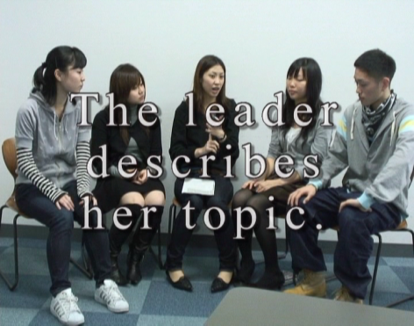 | 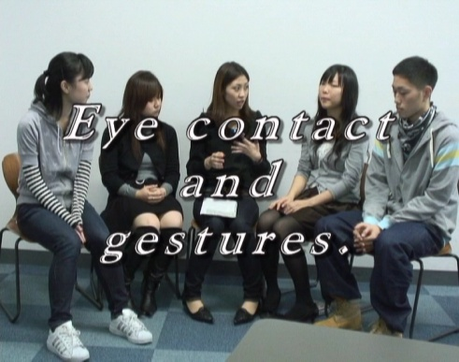 | 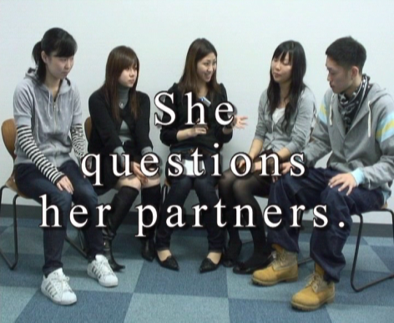

Useful Expressions for Students to use to Talk about an Article and to Teach Vocabulary
The topic of my news story is…
My news story is about…

Do you know the word…?
Have you ever read/heard of the word…?
Do you know what ________________ means?
Are you familiar with the word…?
The first/second/third/fourth/fifth word in my vocabulary list is…
_________________ is a noun. It is a person who _________________.
_________________ is a verb which means _________________.
The adjective, _________________ that describes _________________.
_________________ is like/ similar to good and it means _________________.

Figure 3# Useful Expressions

Teaching discussion skills such as the use of follow-up questions should be an ongoing activity in class. Each week, you should focus on a different aspect of it. The following table shows different game-like activities that emphasize effective discussion behaviours such as eye contact, participation, and the use of gestures. It also includes extensions to the task to increase its complexity once students become accustomed to participating in small group discussions.

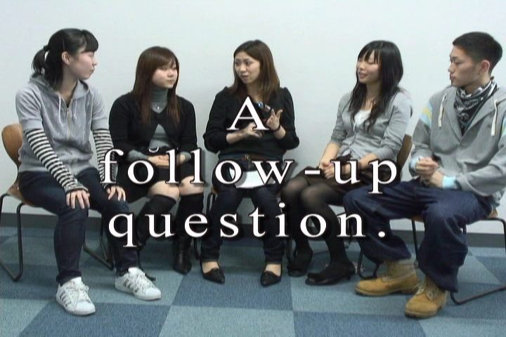

Discussion Teaching Activities
1. As a class, students form a circle and play “wink murder.” (See detailed explanation below.) In this game, students face each other while one student, secretly chosen by the teacher, is the murderer who blinks twice, killing the person opposite.  2. Students learn how to use gestures by saying a word  and doing the appropriate gesture.  3. Using a check sheet, students count how many times  they use a particular speech act.  4. While engaged in small group discussion, students  are rewarded with a counter or poker chip each time  they take a turn. The winner has the most chips at the  end.  5. To sensitize themselves to eye contact, students  participating in a discussion draw slips of paper  that identify them as high or low eye contact.  Afterward, students guess who drew which slip.  6. In a similar type of activity, students find themselves  designated as a high or low user of gestures, or a  non-user. Other students watching them count the  number of times that the discussion leader or  participants make eye contact, use gestures, or  follow-up questions. | 7. Another activity might be for students to prepare  record the discussion and then transcribe it at home.  By reading and making comments, students will  focus on the grammatical forms.  8. As they improve their abilities in subsequent classes,  ask students in the discussion groups to take turns  shadowing the discussion leader. The leader speaks  for a few minutes, then a student has to paraphrase  what he or she just said.  8. Another useful variation is to have the discussion  group leader paraphrase his or her partners’  responses to the questions. After the discussion, the  leader summarizes these in front of the class.

Figure 4# Discussion Teaching Activities
Wink Murder is a party game. The practical minimum number of players is four, but it can be played with as many as 35 players and up. In each round of play, one player is assigned the role of murderer (or 'Killer'), with the ability to "murder" other players by making eye contact and winking at them. If a player is winked at, they feign sudden death and are removed from the game. Other players are forbidden from winking. The objective of the murderer is to murder as many people as possible.
In one variation of the game, another player, unaware of the murderer's identity, is assigned the role of "detective". All other players sit in a circle around the detective, whose objective is to correctly identify and accuse the murderer, minimizing the number of murder victims. A limit is often imposed upon the number of accusations the detective can make. In this version of the game, players other than the murderer and detective do not necessarily know the murderer's identity, and have no role to play in the game other than to die noticeably if winked at.

I.(g) ONLINE RESOURCES
The following websites offer news that can be read online, but also have a multi-media component so that students can hear the same news article read to them, and in some cases, watch a video as well, making the task an even richer one.
And there are many online versions of well known newspapers, accessible through Online Newspapers Dot Com at http://www.onlinenewspapers.com.

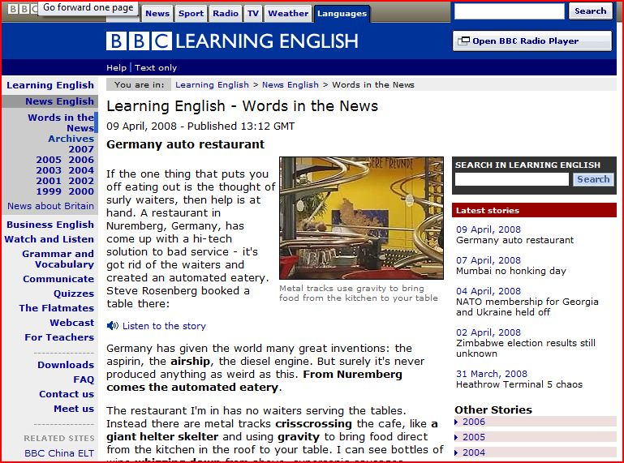
Figure 5# Screenshot of BBC Learning English

(1) BBC Learning English
This site includes news articles, audio files, and a vocabulary list. You can hear the story being read and watch video content, too. The website has other useful features for learners such as crossword puzzles, exam skills, games and quizzes, grammar tips, and an online community of language learners http://www.bbc.co.uk/worldservice/learningenglish/newsenglish/

Figure 6# Another screenshot of BBC Learning English

(2) Literacy Works
A very special project by Literacyworks, the Western/Pacific Literacy Network and CNN (http://literacynet.org/cnnsf/instructor.html)offers both a newspaper article, and audio and video feeds. The website also includes an instructor page, and an outline of the article, and in some cases, cloze exercises, too. Most of the articles date from 2005 and there are a limited number of them, so a teacher assigning the website for class newspapers would have to track which articles had been used in class.


Figure 7# Screenshot of an article from Literacy Works

(3) NHK
NHK offers a section on their website which provides the text of a short video (http://www.nhk.or.jp/daily/english/10_14.html). In this case, students could watch the video, read the script, copy (http://www.nhk.or.jp/daily/english/10_14.html). In this case, students could watch the video, read the script, copy the script, and hand this in with their newspaper discussion materials. The news is up to date, and on video, making it very high interest, and yet the site still offers a written text.

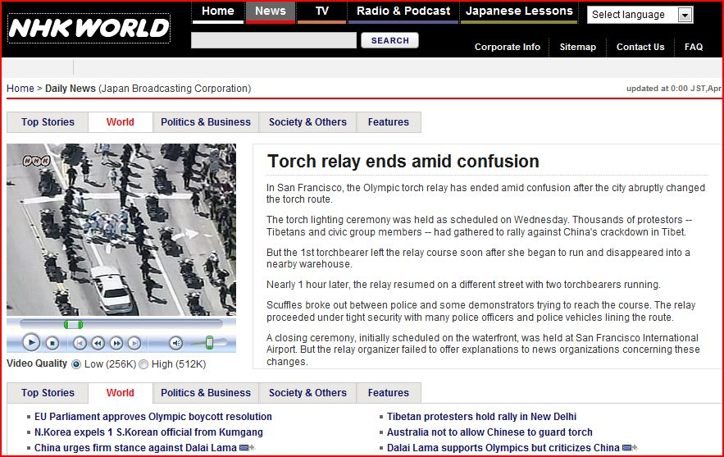

Figure 8# Screenshot of NHK, English World website

(4) The New York Times
This online version of the newspaper offers current news but also includes links for the back story and in some cases, transcripts of podcasts. As with other websites sites, the web version of the newspaper story has been simplified: http://www.nytimes.com/pages/todayspaper/index.html.

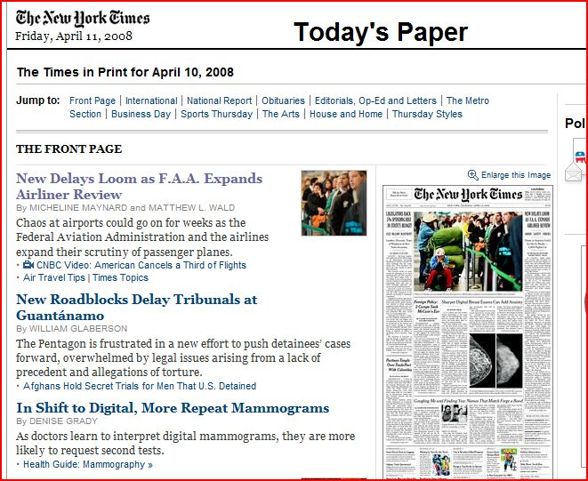

Figure 9# Screenshot of The New York Times website

(5) The Voice of America: Special English

The Voice of America provides simplified news articles on such varied subjects as agriculture, lifestyle, science, and famous Americans and spoken versions of those same articles. The website (http://www.voanews.com/specialenglish/archive/index.cfm?month=3/1/2008) has a Special English section which offers audio files and the transcripts as well. However, there are fewer articles available than on other sites and the news is not breaking news.

Special English Archive
Use the calendar below to find a Special English script from 2001 - present.
The scripts are organized by year, month, and week.
Click on a number to find all scripts broadcast in that week.

2008
Jan |  |  |  | Feb |  |  |  | Mar |  |  |  | Apr |  |  |  | May |  |  |  | Jun |  |  |  | Jul |  |  |  | Aug |  |  |  | Sep |  |  |  | Oct |  |  |  | Nov |  |  |  | Dec
1 | 2 | 3 | 4 | 1 | 2 | 3 | 4 | 1 | 2

Figure 10# Section of an article from VOA, Special English

The website also includes topics such as American Life, Health and Science, Entertainment, Leisure, Science and Technology and news from the Americas, Africa, Europe, and Asia.
You will need to direct students to particular programs. The site also offers the opportunity for students to choose articles based on different themes.

I.(h) DISCUSSION SHEET SIGN-UP
It is very important to schedule the discussions well in advance. This can be done by circulating a sign-up sheet among the students in your class. However, you must limit the number of people who are allowed to sign up for a particular date. Otherwise, none of the students will want to sign up for the first discussion.

A good sign-up sheet can be produced using Excel as in the example that follows, Figure 11#

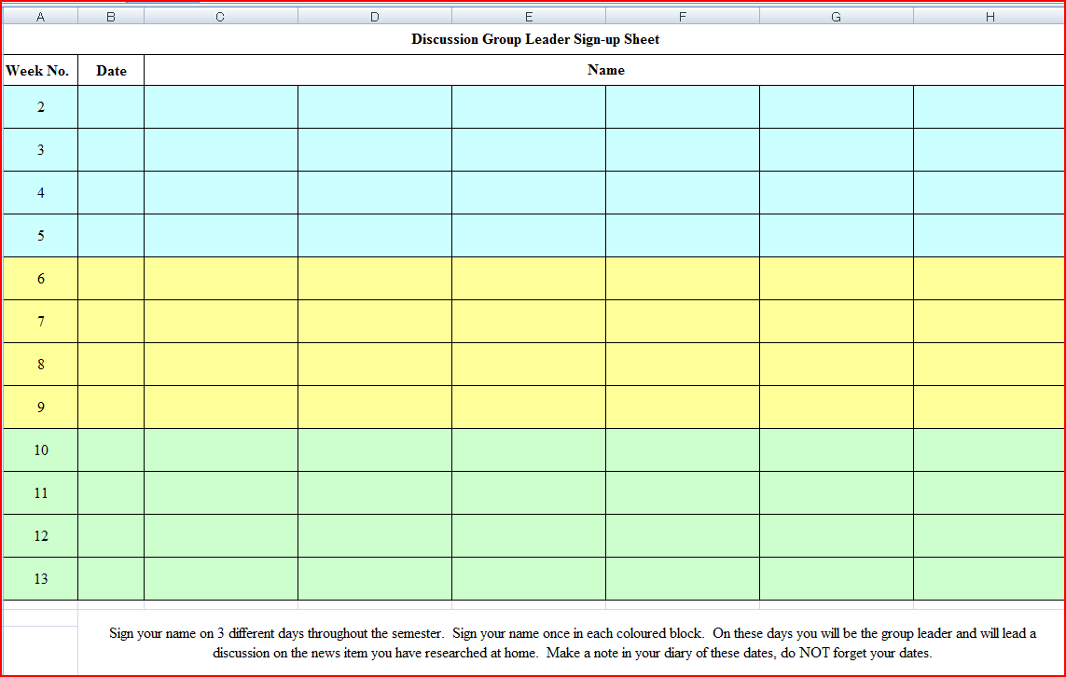

Figure 11# Discussion Leader Sign-up

APPENDIX 2
Tomomi Tsunoyama

NEWSPAPER SUMMARY: CE 3
Passengers the Real Heroes: Bus Driver

AJuly 14th, 2008
62-year-old bus driver attacked by two youths on Thursday says his bus passengers were the heroes.
David Newton wrote a letter to The Bulletin yesterday, reassuring family and friends he was OK after being punched in the head outside Australia Fair about 1.20pm.
"A passenger advised me that youths were spraying graffiti on the bus using spray cans and special marker pens," he said. "I caught them in the act and advised them that I was calling the police.
"These youths then tried to escape from the bus without success, as I was assisted by a passenger. They then turned violent on me.
"But after I defended myself and with the assistance of another Surfside driver, they gave up."
Mr Newton said three youths then escaped through the rear skylight hatch of the bus.
"Many people have contacted my family, work and talk back radio about the incident, and I wish to advise them all that I only received minor injuries in the incident," he said.
"I wish to thank a New Zealand tourist, Jim McDougall,
who assisted me in preventing the youths from escaping as well as the prompt action of the police.
"My special hero is a lady named Amber who not only rang the police on her mobile phone, she also took photos of the incident and was able to give the police very good descriptions of the offenders.
"I have since contacted her and she and my wife are going out for a celebration drink for a successful outcome in catching these offenders.
"The good news is that a mobile telephone was found in the skylight.
"On investigation, the police were able to track the owner.
"The phone supplied plenty of photos of other graffiti incidents that the youths have performed.
"A lot of people have asked me whether this incident would put me off bus driving.
"My answer is no, because I am not going to let an incident like this upset me. More than 99.9 per cent of our passengers are a pleasure to deal with."
Three of the youths involved in Thursday's incident are helping police with their investigations. Police are still looking for two of the teenagers.

[Errors of grammar and word choice have not been corrected.]
14 July 2008
Source of the Article:
“Passengers the Real Heroes: Bus Driver”. The Gold Coast Bulletin. 14 July 2008
<http://www.goldcoast.com.au/article/2008/07/14/13642_gold-coast-news.html>.
Who? ----- David Newton
What? ----- was punched
When? ---- Monday 14 July 2008
Where? ----Australia Fair, Southport
Why? ----- Telling off youths making graffiti in the bus
How? ----- A passenger told him that there were youths vandalizing the bus

Vocabulary
Attacked –trying to harm someone or something
Graffiti – paint or writing on something that spoils its appearance
Advised - gave someone some advice or information
Violent - injurious or destructive force
Hatch - an opening that serves as a doorway or window in the floor or roof of a building.
Summary:
A 62 year old bus driver named David Newton was attacked after telling off youths about spray painting graffiti on the bus. While getting off the bus, a passenger informed Newton that there were youths in the back of the bus, spray cans and special marker pens, spraying graffiti. Newton caught the youths in the act and advised them that he was going to call the police. The three youths tried to escape from the bus, but another passenger stopped their escape, and the youths became violent. Then some of the youths escaped through the rear skylight hatch of the bus.

My opinion:
Graffiti is a big problem within Japan right now as it was discovered that a group of university students have “tagged” one of the world heritage buildings in Italy. Later it was also discovered that a baseball coach of a famous high school had also vandalized a world heritage place. I don’t understand why people would vandalize such famous buildings. It is disrespectful to the people who built such monument. Another recent case of vandalism in Japan is the case where a bullet train was vandalized and had the word ‘Hack’ spray painted on. It is believed that the artist sneaked in from the gap in the fence and had around 20-30 mins to graffiti. These people should be made to clean the graffiti, as a punishment, as well

Questions:
- How do you feel about the rise in vandalism?
- What do you think would be a fair punishment for the people who vandalized?
- Why do you think young people vandalize objects?

II.(b) NEWSPAPER MINDMAPS
You may need to introduce students to the practice of mindmapping to assist them with writing their newspaper summaries. The activity begins with the use of short newspaper articles. Then ask students in small groups to read an article quickly. Everyone in a group has the same article. Tell them to skim the article for general ideas, and mention that they will find out what they don’t know afterward by asking questions of the other members of their group. After a short period of time, ask the students to turn over their papers and tell each other what they can remember.

In their groups, students write down the key words and phrases about the article that came out in their discussion. Then they transfer the information to a “mindmap” of the article, placing the topic in the centre and connecting the main ideas.

The main ideas should have supporting details by them. After each group has finished a mindmap, the group members copy it, and the teacher collects it. Then each group member joins a new group to explain the mindmap and the article. Alternately, students in pairs could explain their articles.

Explanations should be of sufficient detail, so that their partners can accurately give an oral summary of what they have heard. Then the students can offer some opinions about the articles. Time permitting, students who have heard about the articles but have not read them, can be allowed to read them to confirm how much they understood. You might also have them create role plays based on events from their articles and invent what they believe will happen next. Students can write a summary of the news article, too.

APPENDIX 3
TEACHING VOCABULARY
It is important to find out how many words that your students know. At minimum, they need a foundation, a solid working knowledge of the first 200 word families. There are numerous websites offering the Academic Word List for English and several of them also have exercises. These include the word list developed by the language education program of the University of Nottingham. (http://www.nottingham.ac.uk/%7Ealzsh3/acvocab/teaching.htm).

III.(a) 5 PRINCIPLES TO TEACH VOCABULARY
According to researcher William Graebe, there are five general principles for teaching new vocabulary words to students. It is important to teach them how to use these principles themselves. Also, when using these principles in class, identify them to students.

(1) Frequency of Use
Learners need to spend time both directly reviewing the words and also using them in creating sentences, and in spoken use with others.

(2) Repetition
Learners need to see the new vocabulary in a variety of contexts. The repetitions need to be spaced over time.

(3) Spaced Retrieval
Many repetitions of a word are necessary when students first encounter it. Otherwise, they will not remember it. One of the easiest ways and most time-efficient ways of doing this is making flashcards, or getting students to make flashcards as part of their preparation for a newspaper article discussion. You might collect the cards that they make and keep all the student cards together and then review them briefly at the beginning of class.

(4) Avoid Interference
If two words are similar in sound or appearance with each other, avoid teaching them at the same time. Counsel students to avoid trying to learn words from alphabetical lists. Only teach one word of a word family; teach migrate, do not teach immigrate, and emigrate at the same time.

(5) The Generative Principle
Transfer vocabulary words across several different tasks. Have students use words that they have read in writing their journals, their book reports, or in an IE Writing assignment. Try to use these words in directions to your students so that they hear the words from you. The more generatively a vocabulary item is used (ie. noticing it, receptive retrieval, productive retrieval, receptive generative use, productive generative use), the better chance of learning it.
III.(b) VOCABULARY FROM DISCUSSIONS
Introducing vocabulary is an important part of the small group discussion task. One approach to using it with the newspaper discussion is to have each student leader make his or her own flashcard set and a vocabulary quiz for the articles that they present to their discussion groups. Students decide which words they think are the most important ones that their classmates should remember, for example, five to seven words per article. They then prepare flashcards (of a standard size and appearance so that you can keep them and show them in subsequent classes). Afterward, the discussion leader prepares an oral or written quiz based on multiple choice, synonym, antonym, or matching and has their group do it. It is very important to emphasize to students that their vocabulary words should be common, more frequently used ones than long and obscure ones. You might even suggest that they look for the words on the academic word list mentioned earlier.

The second technique, sometimes called “word web” or “vocabulary brainstorming,” is a whole-group activity led by the teacher and noted on the OHC or chalkboard. The teacher elicits words from the students and draws a mind map of related terms, which may or may not have appeared in the article. For example, the word “election” can be associated with “elect, vote, voter, candidate, dark horse, front runner, ballot, political party” and other terms. These words can be used to make original sentences or stimulate further conversation on the topic. The teacher can record them and periodically question students about them.

One vocabulary game to review vocabulary words in class is the “stand-up-sit down” one. The teacher calls on a student and asks them to think of sentence using the word. If the student gets the sentence right, they can sit down and rest. Otherwise, they must remain standing.

A second vocabulary game is to divide students into teams. Each team makes a list of six or more words from the vocabulary being studied in the class. Each team challenges another team to define the words and use them in a grammatically correct sentence. The team that gets the most right progresses through the competition until there is a final winner. By one teacher’s account, students in his class stayed up late studying so that could win!
Useful Expressions For Teaching Vocabulary

Do you know the word _____?  Do you know what _____ means?  Have you ever heard of the word _____?  Are you familiar with the word_____?  The first word in my vocabulary list is _____.  The second / next third / fourth / last  _____ is a noun.  It is a person who _____.  --thing which  --place where | _____ is a verb that means to _____.  _____ is an adjective/ adverb  that describes _____.  It's how you feel when _____.  _____ is like _____(, but it means _____.)  --similar to  --a synonym of  _____ is the opposite of _____.  --an antonym  For example, _____.

Figure 12# Useful Expressions for Teaching Vocabulary

III.(c) VOCABULARY NOTEBOOKS
Students should also maintain lists of words in a vocabulary notebook that they keep for the class. These words could be assessed through a vocabulary test at the end of the term, or by the teacher taking in the books and assessing them as a type of portfolio assignment.

Figure 13# shows the type of information that would be included in a vocabulary notebook. This form was made using an Excel spreadsheet. This type of student assignment should be assessed frequently. When it is first introduced to the class, you should show past examples of student notebooks to explain what you expect. After the first week, it would be a very good idea to collect all the notebooks and to grade them and later to display some of the better ones.

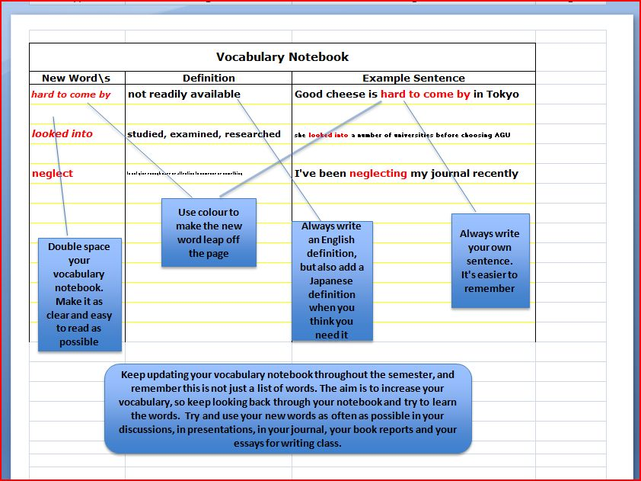

Figure 13# Sample Vocabulary Notebook

III.(d) VOCABULARY LISTS
You should emphasize to students that learning vocabulary items will be learned more effectively the more often they are used. The vocabulary will be reinforced when students encounter them in readings and when listening to films, and news.

Student Self-assessment
Students can quickly and conveniently assess their vocabulary level at...
http://www.er.uqam.ca/nobel/r21270/levels/.

III.(e) VOCABULARY ACTIVITIES

14 VOCABULARY BUILDING ACTIVITIES
1. Brainstorming and Mapping
Assist students in listing related words.

2. Classification
Students classify words into logical categories (air pollution, water pollution, etc.), or structural categories
(nouns, verbs, adjectives)

3. Comparison
Prepare a list of synonyms that students know and ask them to find corresponding words in
the text that carry the same meaning. Alternately, the students could look for contrasting
words and meanings.

4. Context
Get the students to look for context clues that use description, explanation, contrast, or cause-effect to explain the
meaning of certain words.

5. Definition
Underline the words you think students should know and they look them up in a dictionary.

6. Feeling
Get the students to infer the meanings of the words from the mood of the reading, write own
their definitions of the words and share them with their peers.

7. Matching
Give students a list of words and their definitions in a random order and they match them up.

8. Modified Cloze
Students find the missing words in a section of the text where you have cloze key
vocabulary.

9. Realia
Use the actual object or a board diagram to explain a word.

10. Synonym
Look for synonyms the writer uses to convey the same meaning.

11. Roots and Affixes
Students identify root words and their affixes (prefix or suffix) in the text. Discuss their
meanings (educate; education; educable).

12. Modified Cloze
Students find the missing words in a section of the text where you have deleted key
technical or conceptual words.

13. Vocabulary Mime
Choose different vocabulary words from the text and put them into a box. Have students
(or one student from each group) come to the front of the class to pick one up and mime
them for the rest of class or their group.

14. Retelling
Summarize a passage using key vocabulary.

15. Roots and Affixes
Students identify root words and their affixes (prefix or suffix) in the text. Discuss their
meanings (educate; education, educable).

16. Skimming and Peer Tutorial
Students skim the passage to find unfamiliar words, then ask another student for their help.

Figure 14# Classroom Vocabulary Activities

This list can be used to re-introduce vocabulary items from a classroom textbook that you may be using. The point is that teachers should consciously deal with vocabulary in their classes.
APPENDIX 4
ASSESSING DISCUSSIONS
Early in the class, you should show students the sample DVD and ask them to rate the discussion groups. First, show the explanation of the discussion leader’s task, then depending on whether or not the class is CE 1, 2, or 3, show the part of the DVD that needs to be rated (CE 1, 2, and 3 correspond with the same IE levels). The students should then check each group on the following scale. This scale classifies the discussion leader’s efforts in terms of an explanation, questioning, and non-verbal communication. After the students have made their choices, please let them know your score for the groups.

 | Explaining | Questioning | Non-verbally Communicating
3 | a) Described the main points  of the article without  reading  b) Explained vocabulary when  needed, using only English  c) Paraphrased partners’  comments accurately | 1) Asked partners questions,  used their names, and  encouraged their  participation.  b) Used follow-up questions  and rephrased them as  necessary.  c) Employed questioning to  direct the discussion and to  clarify points. | a) Frequent, natural eye contact.  b) Appropriate, helpful gestures.  c) Good posture and sensitivity  to the body language of other  group members.
2 | Any combination of 2 descriptors from a, b, c. | Any combination of 2 descriptors from a, b, c. | Any combination of 2 descriptors from a, b, c.
1 | 1 descriptor from a, b, or c. | 1 descriptor from a, b, or c. | 1 descriptor from a, b, or c.
0 | Read the article aloud. | Read the questions aloud. | No eye contact or gestures.

Figure 15# Assessment Scale for CE Discussion Leaders

IV.(b) STUDENT SELF-EVALUATIONS
A simple form for students to evaluate their own discussion performance is included below. It contains the same three headings as the Assessment scale but the form is a simple checklist. Its purpose is as a reminder to the discussion leaders of what they should do during a discussion.

Self-evaluation should be a regular feature of the small group discussion task.

Discussion Checklist:
A. Explaining
- describes the content thoroughly (without excessive reading from notes)
- summarizes partners’ comments after each question

B. Questioning
- asks partners a variety of questions
d) uses follow-up questions when necessary

C. Communicating Non-verbally
- makes frequent eye contact with partners
- uses gestures frequently (e.g., pointing to a photograph or headline)

Explaining |  | Questioning |  | Communicating Non-verbally
a) describing |  | c) asking questions |  | e) making eye contact
b) summarizing |  | d) using follow-up  questions |  | f) using gestures

Figure 16# Checklist

APPENDIX 5

CE 1: POSTERS

The following explanation on posters for class might be used for CE 1 or as a poster about an interview for CE 2.

V.(a) POSTERS
Posters are an excellent way to create a speaking activity. The teacher provides students with a theme based on the readings or discussions in class. Each student, or each pair of students, prepares an attractive and well-designed poster on A-3 size paper. The following student posters are on the themes of biography and famous people and geography, taken from New Interchange 2. “Ingredients of Good Posters” show a list of the criteria for making an effective poster.

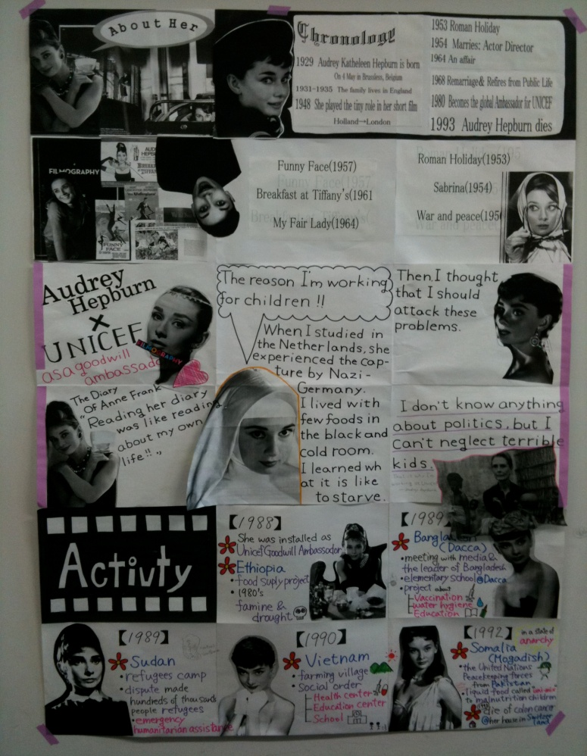 | Ingredients of Good Posters
● Attractive visuals
(charts, diagrams, drawings, maps,
photographs, or graphs)

● Use of lettering
(font, text size)

● Written text
(choice of words)

● Use of colour

● Information

Figure 17# Poster for Biography: Audrey Hepburn
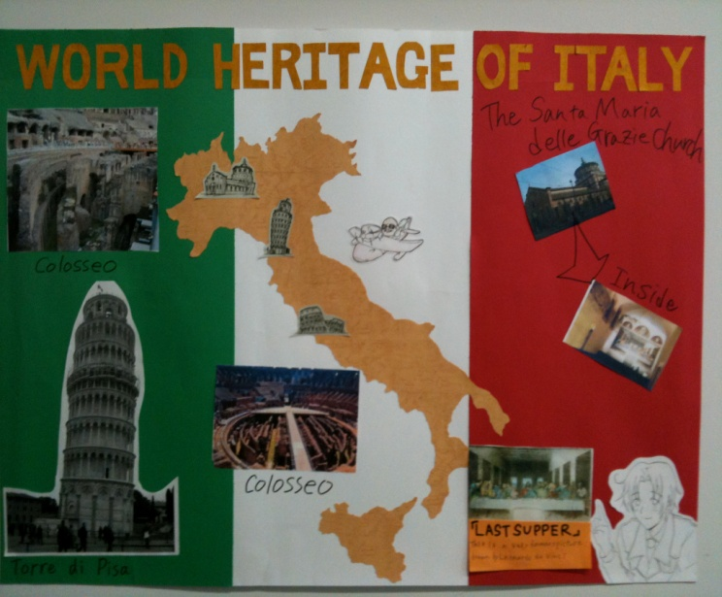 | 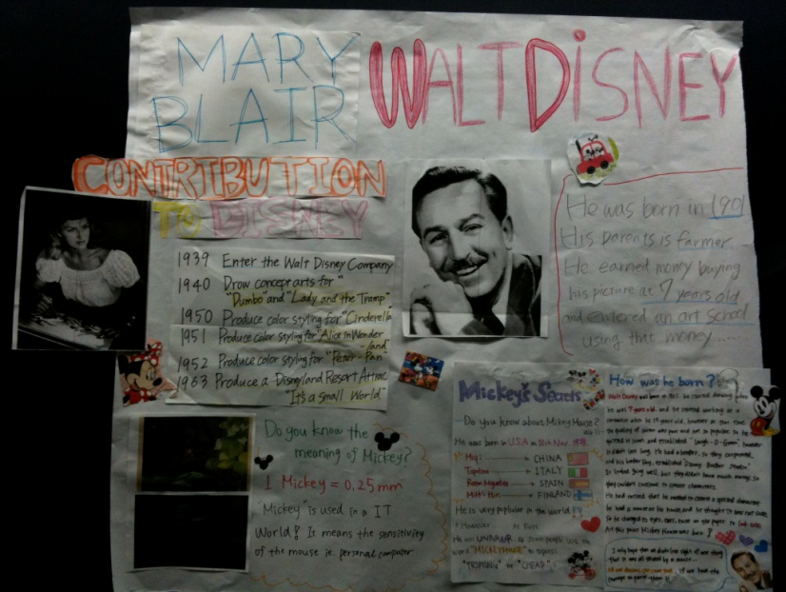

Figure 18# Poster for Geography and Biography: Italy and Walt Disney

V.(b) THE POSTER CAROUSEL
When the assignment is due, the posters go on display in a “poster carousel.” Half the class hangs their posters on the walls with masking tape, (a special tape that won’t damage paint!) and stands by the posters answering questions. The rest of the class views the posters and asks questions. Then you switch the two groups of students. While students are viewing the posters, you might ask them to choose their favourite three posters, and their favourite three explanations of poster. This can be taken up with the class. These student comments can also aid you in rating the posters.

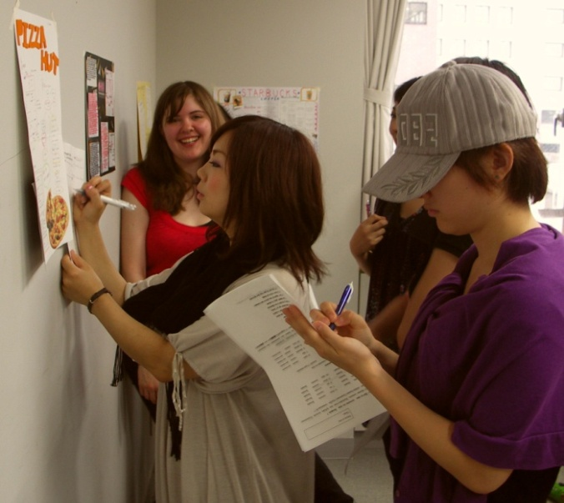 | 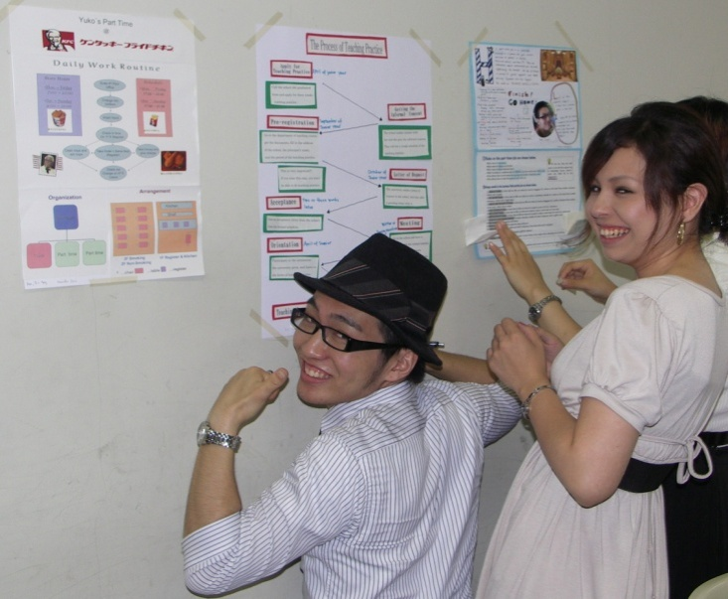
Figure 19# Students participating in a Class Carousel
APPENDIX 6
CE 2: INTERVIEWS
Interview projects can be a fascinating language learning task because students not only have a practical use of language in formulating their questions and then using them, but also because the interviews can provide an opportunity for a cross-cultural encounter. That being said, the interview project should be carefully planned.

Generally speaking, the interview can be imagined as being of two types: one, the sheltered interview, in the classroom, or on a teacher-led fieldtrip. The second type is meant to be done off-campus.

VI.(a) SHELTERED INTERVIEWS
In the Classroom
In this case, the teacher invites English-speaking guests to the classroom. They can be interviewed by students there. This has the added advantage that the teacher can assist students in brainstorming questions in advance of the visit, then help direct some of the questioning during the visit, and lead a good follow-up discussion after the task.

The Class Fieldtrip
Another approach is to take an entire class on a trip to a location where they will have an opportunity to use English. This might involve taking a group to see a play or to visit a community group for foreigners.

VI.(b) A PROTOCOL FOR OFF-CAMPUS
The following interview protocol was developed after hearing of a teacher at a JALT conference whose student had been raped while doing a solo interview. Other teachers at the same conference shared stories which while less apocryphal, pointed out that we should take pains to make the assignment safer for our students. The following measures represent an interview protocol to be taught to students as the protocol that they should follow in this assignment. As teachers, we should also set up the assignment so that it is done in a safe manner, for example, by having students work in pairs, rather than alone.

Also, these suggestions should be role played with students in class, so that they will know how to handle uncomfortable situations.

The Protocol:

- Have your students work in pairs on this assignment for their safety
- Remind students never to accept any invitations to someone’s home
- Students should never give out personal information such as telephone numbers; only their e-mail addresses and this only if necessary
- Tell women students that it is better for them to approach couples or other females to ask interview questions
- A student may feel uncomfortable with an interviewee, and should know how to make excuses and to leave

Figure 20# Interview Protocol for Off-Campus

Interviews at Public Events
One approach for the off-campus interview is to send students to do interviews at weekend community events such as an international school fair, of which there are several at different times of the year (search the school websites for Nishimachi International School, St. Mary’s International School, or Seisen International School, all of which are in the Tokyo area). The St. Mary’s International School has their fair in the first or second week of every May; Seisen International Girls School, always have their fair in mid-October. The other school fairs are also held in early Spring or mid-Fall. You can also send your students to another type of public event like Earth Day, held in April or May in Yoyogi Park.

Interviews at Public Spaces
A second approach is to send students to public places such as the Hachiko Statue or the Hachiko mural at Shibuya station and ask them to approach foreigners who are waiting for friends or who are looking for directions. Then, after assisting them with some information, the student can ask permission to do a short interview. Again, as with other aspects of the Interview Protocol, asking permission, and doing a short self-introduction should be role-played in class.

APPENDIX 7
CE 2: PSAs/CMs
Making a PSA (Public Service Announcement) or a CM, a commercial, can be a fascinating student task, but both must be very well planned by the teacher in order to ensure that the final products are well done and that students have gained in language learning as a result. The other important question is as to whether time spent on the film-making could have more profitably been used in other ways.

VII.(a) PSAs AND CMs
Time needs to be given in class for students to discuss their projects, and for the teacher to work with groups in helping them to refine their ideas. The teacher also provides orientation to a camera, camera angles, videotaping, use of a tripod, and to the editing software available on the computers in our language laboratory. The teacher should also outline a simplified process for creating a film, broken down into pre-production, production, and post-production and tries to keep students on that schedule (see Figure 21#).

PRE--PRODUCTION
- writing the script
- rehearsing it
- storyboarding the camera shots
- finding locations for the shoot
- preparing costumes, props, and
script copies

PRODUCTION
- managing the cast and crew
- filming and tracking scenes
- monitoring film and recording
quality

POST-PRODUCTION
- viewing and editing the footage
- choosing the sounds and music
- adding credits
- producing a video, DVD, and
uploading to a website

Fig. 21# The Student Filmmaking Process

Recent TV commercials can only be viewed on YouTube. However, the Library at Sagamihara (B-520) has an extensive collection of commercials from around the world. Viewing these with your students may help to get them get started.

Among the aspects of this task are that students should learn the use of persuasive language and other forms of rhetoric such as appeals to logic, to a medical or scientific authority.

The most common technique in a commercial is that of an emotional appeal, for example, a commercial of a new car streaking down an open road, the narrator’s voice declaiming its ease, freedom, and power. These could be taught in class and students in groups could improvise short sketches using persuasive language and based on objects that the teacher has brought to class. Perhaps a bag of objects (therefore hidden from view) could be circulated among the groups. Then a person from each group could select the object, for example, a hair brush, or a watch. Students in groups could then create commercials around these objects. Using an “applause-o-meter” (the amount of applause from the group), the class chooses the group with the funniest commercial.

THE LANGUAGE OF ADVERTISING
Advertising may be of two different types: that which is more informative and often found in PSAs; or commercial advertising which relies on emotional appeals. Any number of the following advertising appeals may be used in a single advertisement. (Have students create their own advertisements in the blank spaces.)

- Exagerated claims - These are the most common of advertising strategies. Exaggerated
claims are made for the use of the product.

ie. "This wonderful new breakfast drink will make a difference
to your day."

2. Unfinished comparisons - Unfinished comparisons are made when an advertiser appears to be making a comparison but does not make one.

ie. "Ford LTD---700% quieter."
ie.

3. Weasels or Modifiers - These occur whenever an advertiser modifies a claim.

ie. "Crest toothpaste helps prevent decay."
ie.

4. Preemptive claims - Because they use patented brand names, advertisers can claim their product is unique.

ie. "If the tire doesn't say Goodyear, it can't be polyglas."
ie.

5. "So What?" Claims - In contrast to preemptive claims are claims that are true of all products of a certain type.

ie. "Mobile: the detergent gasoline." (all gasolines are detergents)
ie.

6. Scientific Claims - By using scientific names, the advertisers suggest that the product has been developed
by scientists in laboratory conditions.
ie. "Wonder Bread helps build bodies 12 ways."
ie. "Swedish formula hair replacement."
ie.

7. Vague claims - These are claims that often use metaphors, or other poetic devices to create an emotional appeal.

ie. "A Saab 900 Turbo drives like nothing on earth."
ie. "No one ever promised you a rose garden so you grew your own---American Express
ie.

8. Flattery - Any claims that users of a certain product are better people than
others is an appeal to flattery.

ie. "For those with discriminating taste---Chivas Regal."
ie.

9. Rhetorical Questions - These occur when the advertiser asks the reader a question.

ie. "Are you tough enough to be in the U.S. Marine Corps?"
ie.

Figure 22# The Language of Advertising

Making commercials can take several different forms. It is not necessary that students actually make a film. In fact, there are several worthwhile and less time-consuming alternatives. The first, mentioned previously, is simply to have students act out their commercials in class. The entire process could be done within a single class. A second approach, that of improvising commercials in class could be a step toward writing and photographing one, or recording one. One further point, making a “parody” of a commercial about a ridiculous product (such as a spray that you can use on your car to make it smell new, or a vitamin drink that gives people superhuman powers), is an easy and highly motivating approach.

Refer to these websites for inspiration:

Adbusters — Spoof Ads.
http://www.adbusters.org/spoofads/

Ad Council — View PSAs (public service announcements)
http://www.adcouncil.org/gallery.html

Ads from an Anti-Drug Media Campaign — Watch dozens of ads (many with transcripts)
http://www.mediacampaign.com/mg/television.html

Digital Scriptorium — See American ads in their historical context (also view by category) http://scriptorium.lib.duke.edu/adaccess/

Advertising Jingles — Hear advertising jingles for dozens of food products
http://www.geocities.com/Athens/Rhodes/4190/jingles.htm

Figure 23# Advertising Websites

VII.(b) STORYBOARDS
To plan their shoots efficiently, film directors and film crews employ storyboards showing the action, dialogue and setting in a film. Underneath each of the drawings in a storyboard are commentary, dialogue, and production notes. In much the same way, making a commercial in class should be a process with a number of steps rather than simply letting students wander about with a video camera.

Artist Josh Shephard’s website showcases storyboards for different genres of film (http://www.thestoryboardartist.com/Site/Home.html).
The Department of Education website at the University of Hawaii offers a complete 28-panel storyboard for an instructional video on parking a car (http://www2.hawaii.edu/~ricky/etec/sboardtemplate.html).

The site also includes a downloadable storyboard with blank lines for noting the visuals, audio, transitions, and tracking time. Showing these materials in class can explain storyboards to students as well as provide a framework in which to build their own. Storyboards can also help students to analyze how the plot, conflict, and camera angles of a film contribute to the story. See more examples of storyboards at http://www.sotherden.com/video101/storyboard.htm

STORY BOARD
Speaker | Dialogue | Visuals / Props | Sound Effects

Figure 24# The Language of Advertising

The Photo Strip
Another script-based task series is for students to prepare a storyboard for a commercial with photographs and make it into a poster. This would be a time-saving yet fun approach to making a commercial. Most new laptops have built-in cameras, or the cameras are relatively inexpensive to purchase as an add-on. Shooting snapshots and altering them with such special effects as distorted images, negatives images, sepia tones, or high contrast shots is easy to do.

Comic Life is an inexpensive download for other Mac users and for other platforms such as PC (http://plasq.com/downloads/). It also is available for a free 1-month trial which means that you can ask your students to download it onto their home computers, and create a poster.

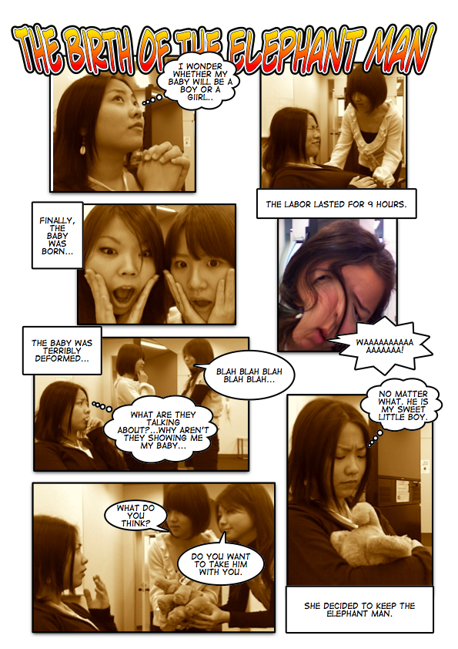

Figure 25# Birth of the Elephant Man
Comic Life allows users to caption photographs with cartoon-style printing, and speech balloons for dialogue and character thoughts. Figure 25# shows a photo strip created in Comic Life by students who went on a fieldtrip to see an amateur theatre production of Bernard Pomerance’s 1979 play, The Elephant Man, a man whose hideous deformities led to his nickname. Students created scenes from the back story to the play, his early life.

Audio Commercials
Again, teachers need to consider whether or not to record at all, then choose the appropriate medium for it. A very low-tech audio recording of a scene can be done with a minimum of equipment and student training: a tape recorder and a blank cassette.

Furthermore, in an audio recording, students can read from their scripts rather than try to memorize their parts. Sound effects can be added to enhance the imagination of both listener and producers. A higher tech solution is using microphones with iPods™ (which can be borrowed from the Computing centre on the 4th F of B Building), MP3 players, or other portable recording devices. The students will also need and a computer for downloading and mixing sound effects such as those available from the Free Sound Project (http://freesound.iua.upf.edu/searchText.php). An easy software program to use is Mp3 Direct Cut which enables users to make tracks for CD recordings. It can be downloaded from http://mpesch3.de1.cc/mp3dc.html. Audacity is a program that enables users to record on multi-tracks; a free download from http://en.flossmanuals.net/Audacity.

Filming Commercials
To begin with, you will need to visit the Language Lab, 3F, B Building and examine our digital cameras, and software. To provide students with an orientation to a camera, camera angles (close-up, medium, and long shots; high and low camera angles, videotaping, and use of a tripod), you might sign out some cameras and then have students in groups practice in class. The Language Lab will also provide an orientation to the Windows-based editing software available on the computers in our language laboratory.
Free online tutorials on filmmaking and editing can be accessed on iMovie Tutorial (http://www.apple.com/support/imovie/tutorial/index.html) and Windows XP (http://www.microsoft.com/windowsxp/using/moviemaker/create/default.mspx).

Students also can edit their films either in the Language Lab, 6F, Goucher Building, or using the Macs in the Computer Lab, Building 2.
Here are the steps in filming a commercial:
1. After showing commercials to your group, help them brainstorm as many products and services as they can
think of within 5 minutes.

2. Following this, groups of students try to develop advertising slogans for a few products, or services.
3. Each group creates a commercial storyboard for homework. [Use the form on page 40.]

- Group members revise these storyboards.

- Rehearsals are conducted before the actual filming.

- Filming should be done outside of class with the use of equipment borrowed from the Media Library (the 3rd
Floor of Building B). If time permits, filming may be done during class time.
Figure 26# Steps in Filming a Commercial
The British Columbia Ministry of Education offers teachers the online curriculum guide for a Fine Arts course in film and drama with very useful learning outcomes, resources, suggested projects, and student assessment scales at http://www.bced.gov.bc.ca/irp/film1112/filpref.htm.

RATING A PSA/COMMERICAL
1. Editing the film: the group showed:
(a) good use of music to suggest different moods
(b) volume control
(c) smooth transitions between scenes
(d) effective narration
2. Film-making: the group demonstrated:
(a) smooth camera operation, without shaking effective use
(b) effective use of close-ups, medium and long shots
(c) effective use of high, low, and eye level angles
(d) panning technique
(e) a zoom shot
3. Script-writing: the writing showed:
(a) a clearly expressed problem
(b) people with different perspectives
(c) a conclusion
4. Storyboarding: the sequence showed:
(a) a detailed record of the different shots planned for the film
5. Total Score for all categories

Fig. 27# Rating a PSA/Commerical

Class discussion of the commercials afterward should focus on 1) how each commercial tried to get the audience’s attention with language, visuals, and rhetorical persuasion, 2) how the characters and the product or service appeared in the commercial, and 3) how likely other students might be to purchase the product.

Further Resources
The major English language news organizations offer various forms of online listening materials, many with broadcast transcripts. CBC TV (http://www.cbc.ca/) and CNN (http://edition.cnn.com/TRANSCRIPTS/) both offer transcripts and video streaming and copies of their broadcasts for sale.
The CBC public affairs program, The Fifth Estate (http://www.cbc.ca/fifth/iceman/index.html) posts key documents of news broadcasts for study. A recent documentary, “The Iceman,” explored the tragic story of Duncan MacPherson, a promising young Canadian hockey player who disappeared after renting a snowboard at a popular Austrian ski resort. With the Austrian authorities “more interested in protecting the tourist industry,” his parents only learned his fate 14 years later when his body was discovered in the melting snow one hot July day in 2003. He had fallen into an unmarked glacier crevasse right in the middle of a popular ski hill. The website includes family photographs, a timeline of events, a missing person’s poster, and a police report. In contrast, CNN (http://www.cnn.com/) offers a large variety of news on business, entertainment, living, technology, travel, and interviews with Larry King with “student transcripts” and DVDs of the news for sale.

Samples of student documentaries can be found online on the Apple Student Gallery (http://edcommunity.apple.com/gallery/student/) or My Hero (http://www.myhero.com/myhero/go/filmfestival/winners2006.asp).

The English department office also has a collection of listening course books with short documentaries and transcripts and videos. These can be used in class to teach students more about the documentary news genre.

When making their own documentaries, students have to understand the fundamental point that a documentary needs content. Students must establish certain key facts in their documentaries: (a) describing their issue, (b) where it takes place, (c) who is involved in it. They will also need some familiarity with on camera announcers and the use of voice-overs.

Filmmaker Michael Moore suggests groups of five to six students brainstorming “hot topics,” developing a list of potential interviewees, storyboarding the documentary and sequencing the interviews, then filming them. Moore’s website also includes exercises in interviewing using clips of celebrity interviewees such as Charlton Heston and Marilyn Manson (http://www.fahrenheit911.com/library/book/index.php).

Student films and documentaries, like other activities employing scripts, may be presented in class. If students burn DVD copies of their work, these can be shown in any classroom or in another venue such as a campus art show, school festival, or open campus event. Student films and documentaries can also reach a larger audience through uploading them to YouTube.

APPENDIX 8
CE 2: SNEAK PREVIEWS:
One very popular task in Night School is to ask individual students to make a class presentation of a “sneak preview” of each student’s favourite TV program, a film, or movie trailer. In the case of TV programs or films, students could rent the videos they plan to show to the class. To rate these presentations, please review the material on presentations later in this Appendix. You may also consider having the students fill out the following movie summary form and incorporate it as part of their presentation. It can help direct their thinking about the film and discourage plagiarism of movie reviews as well.

VIII.(a) MOVIE TRAILERS
Movie trailers are the easiest type of project for students to tackle and understand because of their length (try imdb.com, the Internet Movie Database, or simply have students google the name of the film and the word “trailer” to find a trailer for their film). They are of high interest, but short enough to show in class, and for students to prepare exercises for. They can be conveniently shown in class by arranging, for that evening, to hold your class in a CALL room with internet access. Then students can easily show movie trailers that they have accessed on their home computers. You can also assess student work fairly accurately by requiring that students provide a transcript of the movie trailer and exercises for their classmates. This would make a good term project and fully engage other students in the class, too.

SAMPLE MOVIE TRAILER QUESTIONS:

Batman Begins. Url: http://matttrailer.com/batman_begins_2005. Each student hands in these pre/during/post-listening questions and as part of their presentation, students explain their choice of video and describe its contents.
- Pre-Listening Questions
- How did “Batman” get his name?

- This is the 5th Batman movie. What were the names of the other four?

- Many actors have played the role of Batman. Which of the following actors has never played Batman? (a) Tom Cruise (b) Matt Damon (c) Tom Hanks (d) Michael Keaton
- Five Vocabulary Words or phrases.
- criminal – a thief, or bad person
- will – the determination to do something
- “journey inwards” – the journey of the mind
- “no turning back” – no chance to change or stop the process
- “more than a man” – Batman will become a super hero
- Order the following sentences correctly as they are heard on the movie trailer.
- Criminal: Where are you?
- Henri: Your parents' was not your fault.
- Henri: The is nothing! But will is everything!
- Batman: Here.
- Henri: If you make yourself more than just a man. If you yourself to an . You become something else entirely. Are you ready to ?
- Henri: You have traveled the world. Now you must journey inwards - what you really is inside you. There is no back.
- Fill in the missing words.

- Post-Listening Questions
- Why are super-heroes so attractive these days?
- Who is your favourite super-hero and why?
- If you could have a super power which one would you choose and why?
- On the humorous side, what would be some problems with being the boyfriend or girlfriend of a superhero?
Figure 28# Listening Exercises for a Movie Trailer

VIII.(b) RESPONDING TO A FILM/TV PROGRAM
To avoid any plagiarism and to encourage students to thoroughly engage in an intellectual and emotional response to a film, it is a good idea to show students examples of film previews. These can be found on YouTube. Furthermore, you should have them use a standard form to develop their responses.

Film/TV Program

Title:
Your Name:
Student Number:
Date:

Part I. Paragraphs. (Answer the questions on a separate piece of paper):

1. How would you rate the film on a score of 1#( very poor) – 5# (one of
the best!). Why would you give it these ratings?

2. Which two characters did you like best in the film? How are they like
are unlike you?

3. What is the setting in the film? What place that you have visited does
the setting remind you of?

4. Were you surprised at the climax of the film? Why or why not?

5. What is the theme of the film? How do some of the incidents in the
film support the development of that theme?

Figure 29# Response Sheet (A) for a Film/TV Program

New Vocabulary and Expressions
Part II.
Record 9 new words/expressions that you learned from the movie. Use an English-English dictionary to look up the meanings.

English Word/Phrase | Meaning in English

Figure 30# Response Sheet (B) for a Film/TV Program

APPENDIX 9
CE 3: INDIVIDUAL OR PAIR PRESENTATIONS
The ability to make an effective presentation to a group is a very important skill whether students are going on to take graduate school business school courses, and eventually join the corporate world, or simply trying to improve their English by completing tasks in the course, or whether they hope to enter the workforce after high school. The following descriptions explain how you can get students to collect data for their presentations.

IX.(a) SURVEY PROJECTS
This task involves preparing an outline, an introduction, main points, and a conclusion. It also includes developing visuals for use in a presentation, conducting community interviews, collating the findings and generalizing from them. A class developing surveys for the theme of the Environment could have groups working on recycling, use of public transportation, energy consumption, and appreciation of nature.

One working on the theme of the Media could have groups working on TV news, radio, TV drama, movies, and newspapers. A group could ask questions such as "How many hours of TV do you watch each day?" How many TVs have you got?" Who's your favourite news anchor?"

You can prepare students for doing surveys by conducting practice surveys in your class. The kinds of problems students encounter are in formulating appropriate questions and overcoming their shyness about asking questions.

Students should be encouraged to create survey items which elicit a wide variety of response types: 1) those that ask for numbers [i.e., How many newspapers does your family subscribe to? (a)none, (b)one, (c)two, (d)three, (e)four or more], 2) those asking respondents to make a choice from a limited number of possibilities [i.e., “Which type of movie do you prefer? (a)Romance, (b)Adventure, (c)Comedy, (d)Horror, (e)Science Fiction, (f)Other], and 3) ones requiring open-ended responses [Tell about the scariest experience in your life?]. Students should find ways of picturing their data using bar graphs and pie charts, etc. (Excel can be helpful in this regard).

As for dealing with student shyness, practice in formulating questions and asking them in role plays is an excellent way to build student confidence.

Teachers using computer rooms can have students generate their surveys at surveymonkey.com—a service for generating online surveys; the free mode is more than sufficient for the small-scale surveys our students will be creating.

SURVEY PRACTICE
1. Hand out slips of paper to your students. Ask them to write down an answer to 3 questions (a),(b),(c),(d):
(a) Have you been abroad?
(b) How long does it take you to travel to the Sagamihara campus?
(c) How many people do you live with?
(d) Are you the eldest child in your family? The middle? Or the youngest?

2. Collect the papers.

3. Ask for several student volunteers to help you record the answers on the board.

4. Once all the data has been collected, show the students how you could
represent it using different kinds of visuals:
(a) pie graph for the percentages of those who have been abroad, etc.
(b) bar graph for the travel time
(c) line graph for family size
(d) proportional figures for birth order

Figure 31# Survey Practice

IX.(b) COMMUNITY SURVEYS
Community surveys where students survey each other, family members, people in the community, or native speakers are an excellent way to teach students about rudimentary ethnographic research and to interest them in the activity. There are many possible topics. These could be brainstormed in class and include such issues as tuition and entrance exams.

The students should meet again after gathering their data so that they can interpret it. You may suggest some methods of categorizing the data, such as by correlating certain responses with sex and age. Afterward, each group makes a presentation to the class, taking questions from the class. Students should be encouraged to use visuals instead of reading from their notes.

Follow-up activities after the presentations could include summary writing. Differences in opinion about the data could even generate topics for a class debate.

IX.(c) EMAIL AND COMMUNITY SURVEYS Several CE teachers do computer survey projects in class. This is an excellent way to encourage students to become more familiar with computers. It is also a good way for them to learn English because they will be making contact with other students through English.

1. Online surveys can be carried out in a variety of ways. One way is to have students join an Internet group (for example, http://www.yahoogroups.com/) related to their topic and submit survey items in a message to the group.

As most students will not have had experience with electronic groups, such as yahoo groups or google groups, it is worth familiarizing them with the basics of ‘netiquette.’
A much more simple approach is to have students submit their survey items at a site that is intended for the exchange of surveys by ESL students and those interested in cross-cultural exchanges. It can be accessed at http://www.iecc.org/survey/. A third method is to make use of surveymonkey’s free mode at http://www.surveymonkey.com/.

2. For both email or web surveys and community surveys, the next step is the same. Students generate survey questions, perhaps 10 different questions for each group of four.

3. Class time should be set aside for group meetings and data collation.

4. Additional follow-up activities could include having students write summaries of what they
have heard, a kind of simple comprehension check. Other activities might be a class debate on
controversial issues raised by the survey.

IX.(d) RATING PRESENTATIONS
When your students make their presentations, you should require them to prepare detailed notes and create visual aids such as OHCs, handouts, or Powerpoint slides. However, it is very important for them to practice delivering their presentation and avoid reading at all times. This is something that could be scheduled in class time. In general, your students will need prompting and structure to do this well.

A presentation is a performance. Your students need to think of the physical aspects of it as well as the visuals that they will show to the class and how they will present the information.

The 3 parts of a presentation to consider are the Physical Aspects, Visual Aids, and Speech Organization. The physical aspects include nonverbal communication as in an IE Discussion, but also your tone of voice, delivery, and your poster. Visual aids include handouts, OHCs, and Powerpoint slides. Finally, a good speech should be organized in the same way as a paragraph or an essay.

This means that a student’s speech organization should have an (a) introduction, (b) a body (consisting of several points that you wish to make), (c) transitions (to move from one point to another), and (d) a conclusion. An excellent resource, available in the English Dept library is Harrington, D. and LeBeau, C. (2009) Speaking of Speech. (rev. ed.) Macmillan Language House: Tokyo. It includes a DVD of sample student presentations.

Physical Aspects | Visual Aids | Speech Organization
● Avoided reading from  papers or notes as much as  possible  ● Made eye contact with the  audience  ● Used gestures  ● Spoke clearly and with  an attractive tone of voice  ● Spoke loudly enough | ● Used attractive visuals that  might include  photographs,  board notes or sketches,  models, powerpoint slides,  or web sites  ● Explained them carefully  ● Operated a-v equipment  smoothly and effectively | ● Introduction  - Greeting  - Overview of main points  ● Body of the talk  - 1st point  examples  - Transition  - 2nd point  Examples  - Transition  - 3rd point  examples  - Conclusion  - Reminder of the 3 points  - Thanking the audience
Figure 32# Speech Organization

Students need to be taught the importance of transitions in making a presentation. Of course, some of these same transitions can be very useful in writing as well.

Introducing | Moving Along | Concluding
- Let me begin with…  - First of all…  - In the first place…  - To start off…  - In the beginning…  - It started with… | - Next…  - Now, I’d like to go to…  - Now, I’ll move to…  - Concerning… | - To conclude…  - In conclusion…  - In summary…  - To sum up…  - Finally/ in the end…  - All in all…

Figure 33# Transitions in Speech.

The following scale (Figure 32#) is one that is used by Active Listening teachers in the IE Program at the Sagamihara campus. Its advantages are that it includes columns to score two speakers, and to evaluate students in the different roles of emcee or co-presenter.

PRESENTATION checklist

Topic: | Date
Students: | A | B
1. Good posture and appropriate eye contact with the audience

2. Spoke fluently, referring to notes only occasionally

3. Spoke clearly and with an engaging tone of voice

4. Chose pictures and other visual aids well

5. If working in a pair, effectively introduced a partner and the topic. If a co-presenter, a self-introduction with
his/her part of the topic. If presenting alone, introduced the topic well

6. Used appropriate transitions such as “first of all,” “another,” “next,” or “in comparison,” etc.

7. Summarized his/her part of the topic well.

8. As a co-presenter provided a conclusion for his/her part of the topic. If the emcee, a conclusion to the entire
presentation.
9. Chose a video of appropriate length and content.

10. Provided opportunities for the audience to participate by answering questions, and other tasks.
Comments: | Final Score
Figure 34# Presentation Checklist

APPENDIX 10
CE 3: DEBATES
The group presentation has already been described in Appendix 6. Two other potential CE 3 tasks are debates and short documentaries. They will require you to work on them with students over a period of weeks with the actual debate taking place in the last class, or depending on the size of the class, the last two classes. The PSAs or Commercials should be shown in the final class. Again, this task should be approached step by step: story-boarding, listing possible interviewees, etc., and refined over time.

X.(a) DEBATES
Debates can be a very motivating way for students to develop their language skills. They also introduce transitional phrases that can transfer to writing. To introduce debates in class, you will need to explain the idea of the two teams, the affirmative and negative sides. These two sides will argue for or against a proposition or idea, for example, in the formal language of debate: “Be it resolved that university entrance exams should be eliminated.”

Outlined in Figure 33# is a simple format. Because the Affirmative side speaks first, the first round will finish with the negative side speaking last. The order is reversed during the rebuttal period with the Negative side speaking first. After that, Speaker 1# rebuts the points that Speaker 2# made. On his or her turn, Speaker 3# rebuts the points that Speaker 4# made.

AFFIRMATIVE  1ST Speaker  …That university entrance exams should be  eliminated because they are expensive…  3rd Speaker  …because they are stressful for students  and sometimes inaccurate. | NEGATIVE  2nd Speaker  …University entrance exams should not be  eliminated because they provide universities  with much needed funds…  4th Speaker  …because there is no fairer way of deciding  how can attend a particular university.
ROUND 2: REBUTTAL PERIOD: Speakers’ Order: 2nd, 1st, 4th, 3rd

35# A Debate in 2 Rounds

In terms of time and our students’ abilities, a simple debate might take the following form. Each person in the debate will get 3 minutes to make his or her argument. During the rebuttal period, each person will only get 1.5 minutes. You will need to get your students to practice aloud with one another, the repetition being an important part of their language learning.
As well, students will tend to read their arguments unless they do a lot of practice. Everyone in the class should participate in a debate, so in a class of 24 students, you might six different teams, and three debates. To manage each of the three debates and to increase student interest and involvement, you should ask the students in the class who are waiting for their turns to debate to serve in other roles.

These might include (a) the three judges (to judge the winning side), (b) an emcee (to introduce the proposition and to write it on the blackboard, then to introduce each group and its members), (c) the timekeeper. Each judge should score the debate while listening to it.
Afterward, the judges should meet outside the classroom and compare their scores to determine the winning side. While they are outside the room, you might also ask the rest of the class to vote on which side that they thought won, and who the best single debater was.

The form in Figure 36# can be used to judge individual debaters. By adding up the total for each team, the judges can determine the winning side.

DEBATER: | RARELY | SOMETIMES | OFTEN | ALWAYS
Eye Contact with the Judges

Spoke with emotion and enthusiasm

Used several types of arguments:
(ie. examples, authorities, etc.)
Organization (used transitions)

Figure 36# Rating Form for Debaters

Because a debate is a formal argument, there are a number of common phrases that can be used in a debate and it is worth teaching these to students. Activities like those described for learning phrases in discussion in Appendix 1 can be altered and used again here.

DEBATING PHRASES
PROPOSING
• First of all... • It started with…
• I’d like to propose • Let me begin with...
• Initially... • The problem we face is…
• In the beginning…• The best way…
• In the first place…• To start with...
• It’s a choice…• We have to decide…

PROVING A POINT
• According to (an authority)…
• As the data shows…
• I’d like to draw your attention to…
• I’d like to quote…
• In this way...
• Let me prove this point…
• Quoting…

AGREEING
• I agree…
• I agree with you, but…
• I’m in favour…
• I see the point…

DISAGREEING
• Are you saying…?• There is no point…
• Even if/what if … • They fail to prove/explain…
• How/Can you prove it?• They have not proven…
• How do you explain…?• This does not prove…
• I disagree with…• They are exaggerating…
• If we allow this…• This is unbelievable…
• I’m against this…• Unless…
• Evidence is insufficient...• Why do you say…?
• There is no justification…

Figure 37# Debating Phrases

IN CONCLUSION
• All in all…
• In conclusion…
• In summary…
• To conclude…

F

Classical argument or rhetoric was an art developed by the Greeks who categorized the main argument types. These later influenced the development of the essay as a genre of written communication. The most common argument types are as follows.

TYPES OF ARGUMENTS
- Argument by analogy (for example, Women are in the same position as slaves in the Civil War. As slaves
were given their rights, so women should be given their rights, too.

- Argument by appeal to authority (for example, Dr. Morton Tingbolt's research into the area has
indicated that as women's rights increase, so does the rate of divorce. Liberated women are less content so
their husbands have less self-confidence. Tingbolt concluded that women should not be given equal rights.

- Argument by example (for example, Societies such as Sweden or Denmark where women have equal
rights are the most stable, productive, and peaceful on earth. Societies such as Iran or Afghanistan in which
women have the fewest rights are the most warlike. Therefore, give women equal rights.

- Argument by consequence (for example, If women are given equal rights, they will leave their homes and
go to work instead. Unemployment will skyrocket, and families will collapse. Therefore, women should not
be given equal rights.).

- Argument by definition (for example, Women are human beings. All human beings are equal and should
have equal rights. Therefore, women should have equal rights.).

- Appeal to common experience or beliefs (for example, As we all know, women are meant to care for men
and children. This is what they do best. There is no reason for them to be given equal rights. They already
have the right to run a family, the only right they need, the only right they really want.).

- Appeal to emotions (for example, It is unfair to do the same job as a man and to receive less money for it,
just because you are a woman. It is unfair to work for twenty years and be passed up for promotion, time
and again, just because you are a women, to go to a bank and be refused a loan, to be laughed at, not
listened to, treated as an object, just because you are a women. Women need equal rights.).

- Appeal to morality (for example, It is morally wrong to treat anyone as inferior, to place the control of
competent adults' lives into others' hands. All people, should be given the freedom, the right to make
their own decisions. Giving women equal rights is only granting what should have already been theirs.).

- Argument from ignorance (for example, No one knows that anything bad would happen is women were
given equal rights; therefore, these things should be given.).

- "A Fiorti" (Strength) Argument---arguing from a strength such that if someone can do a hard thing then
it stands to reason that they can do an easier thing. If Joe can give up smoking, for example, then he
certainly has the self-discipline to exercise three or four times a week. In another example, the same
argument is applied---if the government can spend $600 million on new atomic submarines, then they can
certainly afford to spend $20 million on daycare facilities for working mothers.

- Argument ad hominem---abusive (for example, Those who say women should be given equal rights are a
bunch of man-hating crackpots and should not be listened to.).

- Begging the question (for example, Women are equal because they are the same as men.
Women are the same as men because they are equal.).

Figure 38# Types of Arguments
Sample Propositions For Debate

1) That there is life on other planets.
2) That flying saucers really exist.
3) That ghosts or spirits exist.
4) That God exists.
5) That watching sports is better than doing them.
6) That women of any age have the right to bear children.
7) That women of any age have the right to abortion.
8) That beauty is only skin deep.
9) That ‘Love Means Never Having to Say You're Sorry.’
10) That ‘When in Rome do as the Romans do.’
11) That could unmarried women should not be allowed to bear children.
10) That women with children should not work.
11) That men and women should share childcare responsibilities.
12) That money can't buy happiness.
13) That capital punishment should be abolished in Japan.
14) That smoking should not be allowed in public places in Japan.
15) That zoos should be abolished in Japan.
16) That people should stop eating meat.
17) That Japan should develop nuclear weapons.
18) That euthanasia should be considered murder.
19) That all cyclists should wear helmets.
20) That letters are better than telephone calls.
21) That life in Japan is better than it was 25 years ago.
22) That it is better to live in the city than the country.
23) That there is life on other planets.
24) That English should be taught in elementary school.
25) That watching TV is a waste of time.
26) That young couples should live together before marriage.
27) That Japan should send troops to Afghanistan.
28) That high school uniforms should not be compulsory.
29) That it is better for couples with children to avoid divorce at all costs.
30) That suicide should be made illegal.
31) That Japan should do more to fight discrimination.
32) That surrogate motherhood is wrong.
33) That honesty is always the best policy.
34) That pet cats and dogs in Tokyo should all be neutered.
35) That Japan should stop whaling.

Figure 39# Debate Topics

There are many potential propositions to debate. The ones you should select should be controversial, of course, but also have a number of arguments that can be made for and against them. Even better topics, or at least topics of greater interest to your students might be found by asking them to brainstorm some.
APPENDIX 11
ADAPTING A TEXT: THE FOUR SKILLS
There are a great variety of potential Oral activities. They can develop from listening, reading, or writing, and in turn lead to activities in these other skill areas. Weaker students need considerable assistance before feeling confident about speaking class, and using a text, or an answer or notes that they have down in advance can help them.

XI.(a) INFORMATION GAPS
Central to the idea of communicative language teaching is the information gap activity. Information gap activities are those language learning activities in which a pair of students work on solving a common problem. Each of the students has a unique piece of information. Partner A might be role playing someone making a phone call about renting an apartment. Partner B would have information about the apartment such as the amount of rent, its location, and size. In information gaps, both students have a need to communicate, and have an equal amount of information to express. Discussions where a decision has to be reached are more or less "opinion gaps" and better students tend to do all the talking. One of the quickest and most effective ways to pair students is to have each student work with the student sitting behind. This way, they cannot read each other's papers. One example of an information gap with a small group of students is to give each student one picture from a sequence of pictures. None of the students is allowed to show his or picture to others, only to describe the picture. Together, the group must decide upon a sequence.
XI.(b) ADAPTING A TEXT
Interchange 2A and 2B feature short reading and listening passages and writing activities that should be used to initiate conversation. Additional activities to enliven the text involve some kind of information gap activity. Highly motivating, they provide a good opportunity for language learning. The following suggestions illustrate different activities using dialogues in the text.

1. Melodrama - students read a passage several times exhibiting different emotions -- shy/confident, energetic/tired, happy/sad, fast/slow, breathless/sleepy, angry/laughing, intelligent/foolish. This could be done with some students drawing cards for the emotions they are to express and then other students trying to guess their emotions.

2. Recreate the Dialogue - after listening to the dialogue several times, students write down what they think they heard. These dialogues are re-read to the class and the students decide which is the most accurate.

3. A Giant Step - encourages students to speak louder because they have to carry on a conversation while standing one giant step away, then two, three, and so on.
4. Prompt Your Partner - where one student with a book prompts two other students with the lines for a dialogue.
5. Eye Contact - while one student tries to make eye contact, the second tries to avoid eye contact;

6. Pantomime Actions - each student lists as many actions as he or she can think of such as tying their a shoe, drinking a can of pop, or brushing their hair which they might do while having a conversation. Then the students read the dialogue and pantomime the actions.

7. Pantomime Response - where one student reads one side of a conversation, and the other pantomimes the replies. The other students in the group guess what the mime is trying to say.

8. What's the Word? - each student selects up to 5 new vocabulary words and writes a sentence for each one. In small groups, each student reads his sentences whistling or shouting "blank" when he comes to the word he chose. The other students in his group have to guess the word.
9. Hangman on Your Back - one student traces out a new vocabulary word on a second students's back. The second student has to guess the word.

10. Word Jam - the teacher shouts out a word, and students in small groups have 3 minutes to think of as many related words as possible. Afterward, the teacher gives points for each "original word," a word named only once.

XI.(c) LISTENING SKILL
Instructors using listening in class should try to keep the material short. Video sequences should be shown several times.

As well, language learners need challenging tasks that require them to focus on different aspects such as comprehension, cultural differences, and vocabulary. You should present your listening tasks in three distinct phases. These are pre-listening, tasks while listening, and a post-listening or consolidation phase. You should give students an activity or specific purpose while watching a video. It is far easier for them to listen selectively than to try to understand everything they hear. Before showing a cassette, or a videotape you should be encouraging the students to think about what they already know about a topic through small group discussion, or brainstorming activities.
When you present feature films to students, you might also encourage students to try to listen for the relationships between the speakers and their respective status.

Students should listen to the material several times, ideally, with a slightly different purpose for each listening. You should encourage them to answer general questions about their listening rather than focusing on individual words and phrases, especially initially. After each listening, you should have students check what they have learned with other students. This allows them to evaluate their own listening and even to identify what they should be listening for when the material is replayed to them.

The Interchange 2A and 2B texts come with cassettes of suitable short dialogues and lectures. There is a wide variety of DVDs and CDs available in the Foreign Languages Lab on the 6F of the Goucher building. The office is open until 8PM and teachers have a 1-week loan period. Transcripts to most popular American films can be downloaded from the Internet at Drew’s Scriptorama.com.

XI.(d) TEACHING WITH VIDEOS
You should never spend an entire class viewing a film. Research suggests a maximum viewing time of 20 minutes even for students who are listening to material in their native language. And experience suggests far shorter viewing times with frequent opportunities for students to respond to the material, or to discuss what they are viewing. If you wish your students to watch an entire movie, then leave the video with the Foreign Languages Laboratory. Make viewing the video an assignment to be completed outside of class time instead of spending so much time on this activity. As well, several resource books on using video are in the English Department teachers= library at Sagamihara. These include Video by Richard Cooper, Mike Lavery, and Mario Rinvolucri (Oxford University Press: Hong Kong, 1991), and Susan Stempleski, and Paul Arcadio, (eds), Video in Second Language Teaching: Using, Selecting, and Producing Videos for the Classroom (TESOL: New York, 1992) and Susan Stempleski and Barry Tomalin's Video in Action (Prentice Hall: New York, 1990).

Prediction Activities
Of the many options for using videos to teach language learning, some of which are described elsewhere in this guide, there are eight approaches to creating prediction activities. These in turn should lead to conversation work.

PREDICTION ACTIVITIES

1. Show only the picture.
2. Play only the soundtrack.
3. Show the pictures to some; the soundtrack to others.
4. Play both the pictures and soundtrack.
5. Play only the beginning.
6. Play only the end.
7. Leave out the middle.
8. Play the sequence out of order.

Figure 40: Video Prediction Activities

In general, teachers using video for language learning should manipulate the video player to create information gaps. Small groups of students working together must find out the missing information. Video technology offers start/stop, rewind/reply, sound on and off, and freeze frame controls that make it possible to play one scene many different ways. Some of the best techniques are summarized as follows:

1. Video Title: Brainstorming - students are given the title and speculate on the content of the video, or where groups of students brainstorm issues or problems related to the video.

2. Semantic Mapping - of great use with nonfiction or documentary material because students anticipate some of the vocabulary and the teacher and students list these in semantic maps.

3. What's the Situation? - show students a scene with clearly identifiable characters, time period, location, and situation, and ask them where? when? why? what? There is a heart-rending scene in The City of Joy where an Indian man and his family coming from rural India look for work, and a home, and are defrauded of their money. Kramer vs Kramer shows the theme of “relationships,” in a scene where Joanna (Meryl Streep) has packed her bag and leaves Ted (Dustin Hoffman).
Steel Magnolias might be used to show “the workplace” theme with a scene where M'Lynn Eatenton (Sally Field) is distraught at the funeral of her daughter, Shelby (Julia Roberts).

4. What's the Message? - use a drama or part of a documentary involving a conversation between two people. Groups of students try to guess what the characters are saying. A comic example is California Suite where Walter Matthau's wife surprises him in a hotel room with a prostitute who has passed out in the bedroom. During the scene, he keeps trying to discourage his wife from entering the bedroom. With documentaries, students write the voice-over narration.

5. 20 Questions - freeze a scene. Groups of students pick an object and their partners try to guess which one it is. The questions and answers should follow a certain sequence: "Is it a piece of clothing?" "Yes." Do men wear it?" "Yes." "Is it his hat?" "Yes, you win."

6. What Can You See? - show a sequence where there are clearly identifiable objects, or items of clothing. Students receive lists of objects, or clothing, some of which appear in the scene and have to check off those that do. Alternately, before showing the video to students have groups of students brainstorm what they might expect to see in the scene. The wedding scenes in Father of the Bride and City of Joy, show the theme of “relationships” or “cross-cultural contrasts.”

7. Sex Change - show a scene which is primarily of men or of women. Ask the students to describe how the scene would like if played by members of the opposite sex. The hair salon scene in Steel Magnolias might work well here as students might suggest a barber's shop with such characters as the local mayor, a college football star, and the groom at a wedding all getting their hair cut.

8. Point of View - choose a short sequence with plenty of action. Form the students into several different groups, each describing the scene from a different point of view. This is also an excellent way to reinforce the concept of the point of view as a literary term. For example, in Kramer vs Kramer, the scene where Joanna (Meryl Streep) has packed her bag and is leaving Ted (Dustin Hoffman) could be described in a first person narrative from Joanna's perspective. It might also be described in a first person narrative from Ted's perspective, or as one from Billy's perspective.
In addition, the story could be told in an omniscient way, and in a third person narrative.
After each group has finished writing their narrative, then new groups are formed with one member from each of the first groups. The members of the new group read their narratives to each other and try to guess which point of view and which character is being depicted.

9. Reading a Part - select a scene from a video for which there is a transcript. Get the students to rehearse a scene and then compare their version with the movie. Among the films for which the English Department has scripts are Anne of Green Gables, Steel Magnolias, Back to the Future, and Working Girl.

10. Eye Witness - choose a scene which focuses on a single character. Ask students to describe the character's appearance. Of the many, many potential scenes are Stand by Me, Battlestar Galactica, and The Unforgiven.

11. Focus on Relationships - students analyze a relationship in a scene. In Kramer vs Kramer, Ted (Dustin Hoffman) learns that becoming a better father means he can't spend as much time on work and his boss fires him.
- the relationship between Ted and Jim is that of ( ) friends
( ) colleagues
( ) boss and employee
How do you know?

12. Timelines - working with "timelines," a line drawn in their books, students fill in the sequence of actions in a scene. In Black Rain, a crooked cop Michael Douglas riding his motorbike, bets he can outrace another biker: in brief, there's an encounter, a challenge, a race, and a payout.

13. Culture Comparisons - students draw a line in the middle of a page writing the name of Japan on one side and another culture on the other. They watch a scene. They list three things that are differ between the cultures and three that are the same. In Back to School with Rodney Dangerfield playing a middle-aged undergraduate, there are some comic classroom scenes of college life in America which could be contrasted with college life in Japan. Alternately, the classrooms in Back to School could be compared to those in Iron and Silk which describes the experiences of Mark Salzman, a young American teacher in China in 1980.

14. What's the Product? - don't show the entire commercial to students but have them guess the product or service being offered.

15. Backwards - choose a complete scene of about 30 seconds showing a character in action. Set the video at the end of the sequence and students reconstruct what came first. Then show the entire sequence, students noting the missing details. One good choice might be to use an action sequence from a Charlie Chaplin film.

16. Captioning - works best with silent Charlie Chaplin films such as The Gold Rush, Modern Times, and City Lights. You stop the scene before the caption is shown and the students write down captions.

17. Realtime Voiceovers - students view a documentary without sound, then write and record commentaries on recorders to be played with the scene later.

18. Strip Dialogues - play a scene for students and give them the dialogue cut into strips. They are to choose the correct sequence for the conversation.

19. Subtitles - students view a scene subtitled in Japanese. Play it without sound and ask them to write the colloquial English for the subtitles.

20. Watchers/Listeners/Readers - the class is divided into three groups in different areas of the classroom. One group watches the film, the second listens to the scene on a tape recorder, and if there is either a transcript or a story, a third group reads it. All three groups have the same amount of time to view, listen, or read and the sequence may be repeated. All three groups are asked where the scene takes place, who is in the scene, how many people are in the scene, what happens, and why.

There are many suitable films that can be used with this instructionally rich technique. One is A Passage to India where Dr. Aziz, a Moslem doctor, encounters Mrs. Moore, an elderly British woman in a mosque. He reminds her that she should have taken off her shoes. This can be supplemented with the reading from the E. M. Forester novel A Passage to India.

Another is Never Cry Wolf. The young Farley Mowat (Charles Martin Smith) enters a wolf den and finds a mother and her cub, a scene which is described in the novel by the same name by Farley Mowat, as well as in Brenda Wegmann, Miki Prijic Knezevic, and Marilyn Bernstein, Mosaic 2, (3rd ed., Singapore, McGraw Hill, 1996), "The World We Lost" by Farley Mowat, (p.44). An additional choice is the scene in Gorillas in the Mist in which Digit, the mountain gorilla is murdered by poachers, an incident described by Paul and Anne Ehrlich in "Extinction," Mosaic 2, (3rd ed.) (p.285).

21. Role Plays and Debates - are based on either the characters appearing in a scene or on an issue raised in a video. Once again, Kramer vs Kramer, is a good choice. Students develop dialogue for the scene where Joanna (Meryl Streep) leaves her husband and son. They can also debate such issue of whether mothers or father make better single parents, whether divorce is easier today than before, and whether 18 is too young to be married.

XI.(e) A SAMPLE LESSON USING VIDEO
The following sample lesson shows how the video Father of the Bride might be used with an IE III class. The initial activity is a survey. Later, working individually, or in pairs, students describe the characters' feelings.

SAMPLE LESSON: Relationship Theme
Class Survey  Previewing Activity:  Father of the Bride | 1. Each student is given an interview question to ask of their  classmates. At the end of the survey, students share their  findings with the rest of the class. Questions might include:  (a) What is the best way to meet a partner?  (b) How long should people know each other before  marrying?  (c) Why do people get married?  (d) What is the ideal age at which to be married?  (e) What are the characteristics of a successful marriage?  (f) What are the characteristics of a unsuccessful marriage?  (g) Why is divorce increasing in Japan?  (h) Should both husbands and wives work?  (i) What are the benefits of a cross-cultural marriage?  (j) What are the disadvantages of a cross-cultural marriage?
Semantic Mapping  Listening Activity:  Father of the Bride | 2. Show the wedding scene in the video once. Then ask them  to working in groups to brainstorm as many names of things,  and items of clothing in the scene that they can. List this  vocabulary in a semantic map on the board. This should be a  competition between groups to see which one can think of  the most objects such as candles, veil, limousine, wedding  gown, bible, organ, tuxedo, and tie.  3. Show the scene again and ask the students to check off the  Items as they see them.  4. List some of adjectives on the board such as: relieved,  nervous, proud, sad, happy, embarrassed, disappointed,  etc. Ask each group to choose one character: the father  of the bride, the bride's mother, the bride, or the groom,  or another character and describe their feelings in a short first  person narrative paragraph.  5. Replay the tape, stopping it as the camera focuses on a  different character. Then have the appropriate group read their  description of the character's feelings. Alternately, get your  students to write letters from one character to another, then  exchange them and write a reply.
Writing

Postviewing Activity

Father of the Bride

Figure 41# Sample Lesson Using Video

APPENDIX 12
STUDENT-GENERATED MATERIALS
Students will enjoy classes where their interests, ideas, and experiences form part of the curriculum. This aspect of the course can be developed through student-generated materials. Some of these materials are listed below:

1. Family Tree - where students present their family tress to a small group. Members of this group might then explain it to other class members in an information-gap activity.

3. Life stories - have students list 10 real or imaginary events in their life on index cards and answer questions on them from other students.

4. Activity Photos - where students bring in photos of themselves doing an activity and report on the pictures in pairs, or exchange cards and assume new identities.

5. Baby Pictures - have students wander around the room, asking questions, trying to match up students with their baby pictures.
6. Neighbourhood Maps - students draw up 2 maps of their neighbourhoods and then give students directions to their house and to local landmarks.

- Publishing - class produces a book together on a fieldtrip, or on a collection of
personal narratives (happy moments, fearful ones, occasions of miscommunication).

8. Class Poems - created with a key line such as "Friendship is ..." Another type is an acrostic where student groups have to think of a noun or a phrase starting with each letter in a key name such as "Neighbour" ("not far away," "elegant"...).

9. Interviews and Surveys - where students bring taped interviews to class about their jobs, or their life styles and ask one another listening comprehension questions.

